Disabilities and Technology:

How We Can Expand Inclusive Education to Achieve SDG 4

Front cover image
A young boy using braille in a special school for hearing and visually impaired children in Oshakati

Vibhu Sharma
Vibhu Sharma is Research Consultant, Disability and Inclusion, Theirworld and the Global Business Coalition for Education. She is a graduate from St. Stephen’s College, University of Delhi and has a master’s degree in inclusive education from the University of Edinburgh. She is also a co-chair of the Global Partnership for Children with Disabilities (Youth Council), a Member of the Global Leadership Council of Generation Unlimited, UNICEF, and a recognized mentor for youth with and without disabilities.

www.gbc-education.org

December 2022

Acknowledgements

This report would not be complete without acknowledging the input and contributions of the many people involved throughout at multiple stages.
Primarily and foremost, I would like to give my heartfelt thanks to Theirworld’s President Justin van Fleet for trusting me to undertake this important project and report on assistive technologies on behalf of Theirworld and for providing all the support I needed.
I am sincerely and deeply thankful to Gordon Brown for the time he spent with me for an interview, in which he provided telling perspectives on what policymakers should be doing to promote access to assistive technologies for children with disabilities everywhere in the world.
Huge thanks are due to the students with visual and hearing impairment and learning disabilities, their teachers, and the assistive technology experts who took time to respond to the survey questions and participate in interviews. Without their responses, we would not have been able to able to form the insights and make the recommendations we have.
I would like to thank my friends and acquaintances who helped to circulate the survey personally, through mailing lists and social media, and my colleagues from the communications team at Theirworld and the Global Business Coalition for Education who put out the call for responses to the survey.
And to all my colleagues and friends, too innumerable to be named here, thank you.

Contents

1. Introduction 4
2. Methodology 11
3. Results and Analysis 12
4. Conclusion and Recommendations 36
Appendices 39
Appendix 1 39
Definitions of disabilities
Appendix 2 44
Types of Assistive Technology
Appendix 3 48
Glossary of assistive technologies
Appendix 4 51
Abbreviations and Terminology
Appendix 5 52
Survey Questionnaire
Bibliography 64

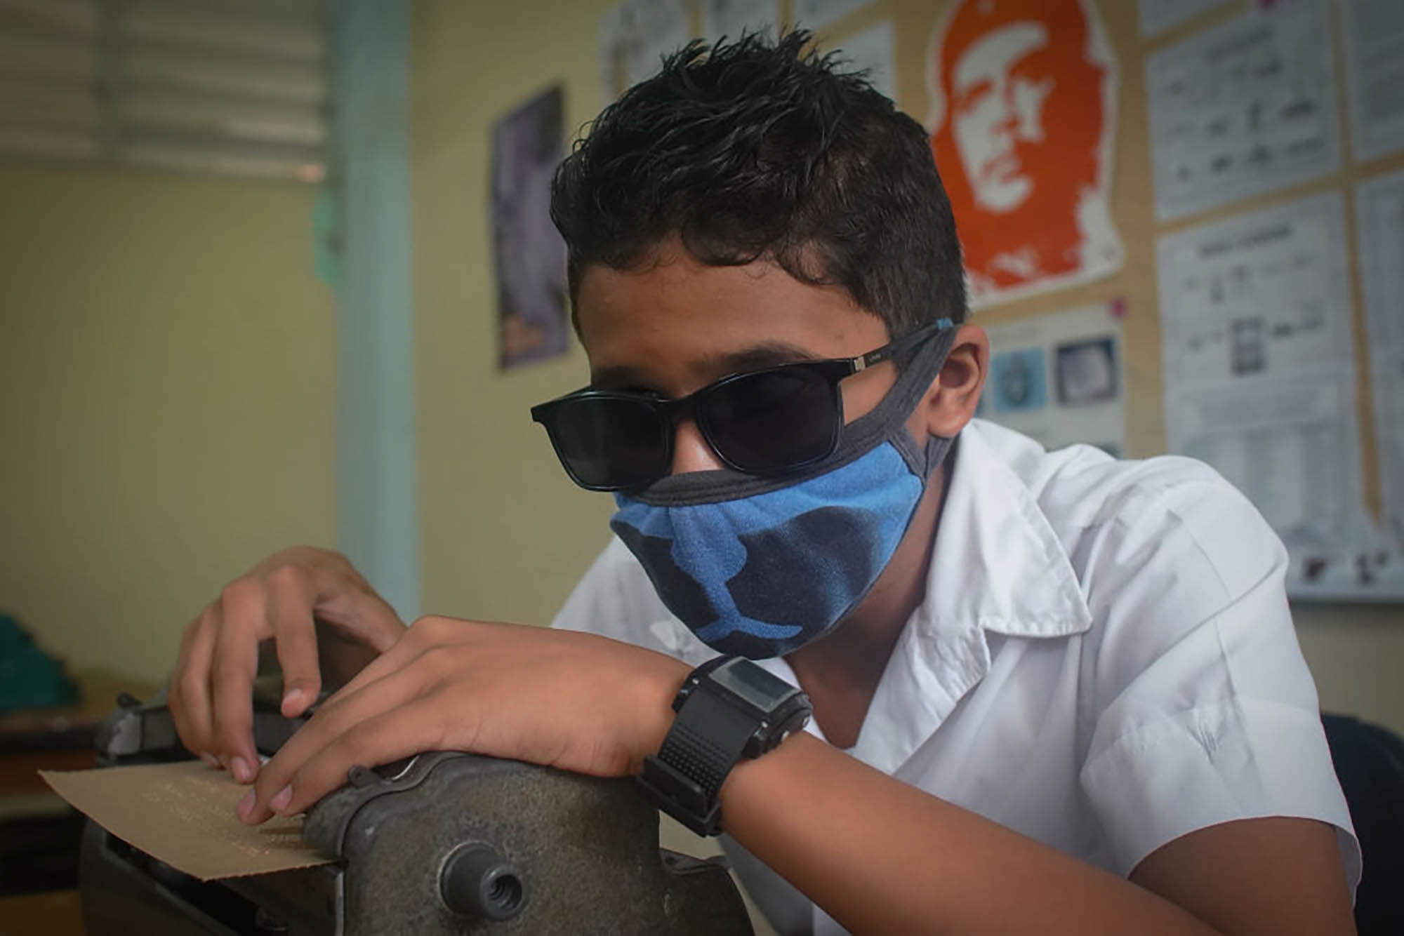
Image on page 4
A visually impaired child in Cuba writes on a braille typewriter during a class at a special needs school for visually impaired children.

Introduction

Inclusive education is a system in which all children, including those with disabilities, are accepted by their neighbourhood schools in age-appropriate, regular classes, and are supported to learn, contribute and participate in all aspects of school life. It means educating children with disabilities in mainstream classrooms alongside their non-disabled peers (Blecker and Boakes, 2010; Haug, 2017).

This ensures that the diverse needs of children with disabilities are met, barriers that may prevent their participation in a common learning environment are diminished, and that they have access to quality education in an accepting, responsive, respectful and supportive environment (Gal et al., 2010). Inclusive education should furthermore concern itself with identifying and overcoming barriers for the continuous, quality and meaningful participation of children with disabilities (Ramchand & Dummugudem, 2014).

The United Nations Sustainable Development Goal 4 states that children with disabilities should have equal access to all levels of education and vocational training. To achieve this by the target date of 2030, it is imperative that the challenges facing children with disabilities in education are overcome and that they are provided an enabling environment in order to reach their full potential. Assistive technology (AT) is critical to achieving that outcome.

Benefits of Assistive Technology

Assistive technology and devices include all those products and services, such as hardware or software, that improve the functioning of persons with disabilities. For children with disabilities, access to AT is the first step for them to be able to go to school, gain an education, and be included in community and society.

AT serves as a powerful tool to enhance a child’s independence and participation. It assists children with disabilities to attain mobility, communicate more effectively, see and hear better, and participate effectively and fully in activities of learning and playing.

Technology has opened up new possibilities and there is growing evidence that it can realize the ambition of inclusive classrooms for children with disabilities. With appropriate AT, persons with disabilities have proven their capabilities and potential to perform on par with their non-disabled peers, be it in education or work (UNICEF, 2017).

Assistive technologies can be simple, such as screen reading software for students with visual impairment, or more complex devices such as speech-generating devices, which require training and greater levels of support. Whatever the level of complexity, AT can help create a level playing field for students with disabilities.

AT helps students with visual impairment access information and reduces barriers to the learning curriculum (Douglas et al, 2011). Technology is also important for the education of students with hearing impairment as it provides accessibility to communication that occurs in the educational settings and also provides a means for delivery of instruction for students with hearing impairment (Stinson, 2018).

AT supports students with learning disabilities by supporting core content areas (e.g., literacy and mathematics) as well as organization and self-management (Courtad and Bouck, 2013).

Assistive technology devices (ATDs) need not always be high-tech technologies, and can sometimes be something as simple as a large printout, or closed captioning in a video. While the use of AT can have a positive effect on children with disabilities, their choice and needs of AT can vary widely, depending on their disability. For instance, children with visual impairment may benefit from materials in braille, notebooks that have raised margins, audio books, and computers with screen-reading software. Children with hearing impairments, on the other hand, require closed captioning or hearing aids. Children with motor disabilities, such as locomotor disabilities, or motor coordination, require the use of a wheelchair, pencil grips and book holders.

Recent major changes in technology have dramatically affected the way we live, study or work, and has also had a significant impact on the ATDs used by students with disabilities. For instance, in contrast to the braille machines that many students with visual impairment used in the past, students can now rely on a regular computer and use a text-to-speech program or a screen-reader to access the same information as their sighted peers. The integration of accessibility features in mainstream technology and devices such as personal computers, tablets and smart phones has improved considerably.

The integration of accessibility features in mainstream devices means more access for students with disabilities to the same opportunities, tools, information and curriculum as their non-disabled peers. There is less need for students with disabilities to be segregated in special education settings. Rather, they can be mainstreamed in general classrooms. Schools and educational institutions furthermore may have to invest less on additional special devices for students with disabilities.

“For most people, technology makes things easier. For people with disabilities, technology makes things possible.” - Mary Pat Radabaugh

Barriers to inclusive education
Around the world, children with disabilities regularly face discrimination which prevents them from going to school. While efforts towards inclusive education have been made in recent years to enable children with disabilities to study in mainstream education, achieving this in practice continues to be challenging. There are huge disparities between inclusive education policy initiatives and the implementation of inclusive practices in the classroom.

Merely giving children with disabilities a seat in a mainstream classroom won’t achieve much towards achieving inclusion if their special needs are left unmet (Florian, 2008). Those needs can only be met properly when schools take responsibility for introducing accessible education and make the appropriate adjustments to suit the learning needs of every individual (Chong and Graham, 2017).

Despite the mandate of many national and international policies, a disability can leave children facing many challenges and often deny them access to education. Students with disabilities, furthermore, are likely to feel discriminated or left out in a mainstream school due to negative teacher attitudes, discrimination and stigma.

The scale of the challenge to deliver AT to all children with disabilities is very high. According to the World Report on Disability produced by the World Health Organisation (WHO) and the World Bank in 2011, out of 100 million children living with a disability around the world, more than 80 percent are in developing countries. In those countries, about 40 percent and 55 percent of primary and secondary aged children with disabilities, respectively, are out of school, compared to 12 percent and 26 per cent of their non-disabled peers (UNICEF, 2016).

According to a 2018 WHO report, more than one billion people globally (adults and children) require one or more types of AT. Yet only one in ten people have access to an AT device that they need (WHO, 2018). Furthermore, a global report on AT, produced jointly by WHO and UNICEF, states that more than 2.5 billion people need one or more assistive products, e.g. wheelchairs, hearing aids, or applications or software that support communication and cognition. Yet nearly one billion of them are denied access to the AT or products they need, particularly in low- and middle-income countries (LMICs), where access can be as low as three per cent of the need for these life-changing products (WHO and UNICEF, 2022).

It is clear that advances in technology have improved accessibility and have the potential to expand access to learning for many children with disabilities. However, the poor availability of effective AT restricts the fulfilment of the fundamental right to education for children with disabilities (Grönlund et al., 2010).

The high cost of AT remains a prominent obstacle. De Witte et al (2018) highlight that the high cost of good quality AT means many ATDs are available to only those who can afford them out of their own pocket, even in high-income countries.

Even when ATDs are available, access can be hindered by a lack of awareness of that availability, limited government support, inadequate policy and legislation mandating the provision of AT, and a lack of trained teachers and support staff.

The situation in developed or wealthier countries is often not that different to children in the developing world, as many young people with disabilities either leave school with qualifications that are insignificant; or dropout of school as they find lessons irrelevant to their lives, or are sometimes placed in specialist provisions (Ainscow and Miles, 2008).

“What we should prepare for is worldwide access to education for young people, and tell educational institutions that they need to make education accessible to everyone. Then, we need to put pressure on tech companies to sell their devices at costs that are affordable for everyone.” - Gordon Brown, UN Special Envoy for Global Education

Given this context of developments in AT mixed with significant barriers to progress, Theirworld decided to conduct research to identify:

- What are some of the most effective technologies for students with visual, hearing and learning disabilities?
- How are they proving to be effective or useful for students with these disabilities, and for their teachers?
- How can AT be made more available and effective?
- How can more affordable ways of providing and distributing AT be found?
- How can awareness be raised about accessibility features on mainstream devices, so they can be more widely used?

We conducted a survey among:
a) children and adolescents with visual, hearing, or learning disabilities,
b) teachers of children with these disabilities in mainstream schools, and
c) assistive technology experts and staff members in non-governmental organisations working in the field.

While ample prior research has indicated that students with visual, hearing or learning disabilities perform well academically and on a par with their non-disabled peers when they have access to AT, there is a lack of research citing the voices of these students, their teachers or experts in the field of AT. We wanted to fill this gap by hearing directly from them, and it is our hope that the thoughtful and revealing responses received will assist the development of policies and initiatives that will place children with disabilities on a level playing field with their non-disabled peers.

The input from three types of respondent and their insight on what AT is useful, how to increase access and how to improve training and awareness, enabled the compilation of several recommendations which are contained at the end of the report.

International framework
The United Nations Convention on the Rights of Persons with Disabilities (CRPD) defines persons with disabilities as persons who have “long-term physical, psychosocial, intellectual or sensory impairments which in interaction with various barriers may hinder their full and effective participation in society on an equal basis with others” (CRPD, 2006). The definition extends to children with disabilities.
While article 28 of the United Nations Convention on the Rights of the Child mandates signatory countries to ensure that all children have an equal right to free and compulsory education, and that educational and vocational information and guidance is available to all children (CRC, 1989), in recent times numerous international political initiatives have increasingly focused on educating children with disabilities in mainstream education (UNESCO, 2017).
UNESCO’s Salamanca Statement of 1994 explicitly focuses on children with disabilities and stresses on their inclusion in mainstream schools, holding that inclusive education is a system in which all schools are prepared to accept and accommodate all children irrespective of their physical, intellectual, social, emotional, linguistic or other conditions, and which is able to respond to the specific learning needs of every individual (UNESCO, 1994).
The ‘Education for All’ movement launched by UNESCO in 2000 reinforces provision of free and compulsory quality education for children with disabilities (UNESCO, 2000). The CRPD, through article 24 on education, mandates that all children with disabilities can access an inclusive, quality and free primary education and secondary education on an equal basis with other children (CRPD, 2006).

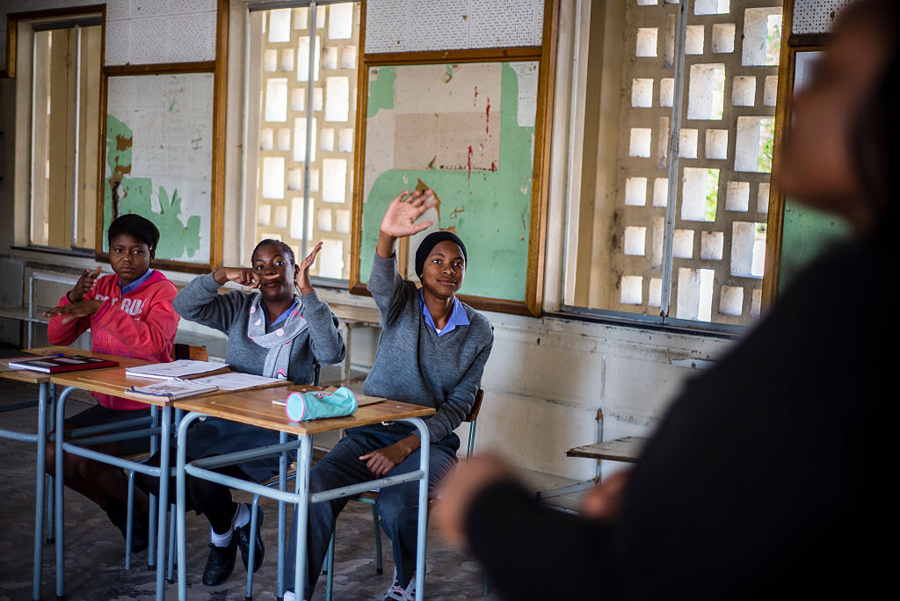Image on page 11
Deaf learners in the ninth grade take a mathematics lesson at Eluwa Special School in Ongwediva, Namibia

2. Methodology

For this report’s survey, a total of 160 responses were gathered through online questionnaires and interviews with people in 39 different countries ranging from Kenya, Malawi, Nigeria, Bangladesh, India and Pakistan to Canada, the United Kingdom and the United States. The responses gathered divided as follows: 107 responses from AT experts, 36 responses from teachers, and 16 responses from students with visual, hearing and learning disabilities.

The 16 responses received from the students were further divided as: students with visual impairment, seven responses; students with hearing impairment, three responses, and students with learning disabilities, six responses.
Three major questions were asked:
- What are some of the most effective technologies for students with visual, hearing and learning disabilities;?
- How are they proving to be effective or useful for students with these disabilities and their teachers; and
- What are the enabling environments for these assistive technologies to be available and effective?

The data gathered from surveys and interviews has been combined to form a consolidated opinion across all nine categories reviewed in this research. Namely, students with visual, hearing and learning disabilities, teachers of students with all three of these disabilities, and responses from the AT experts for each of these disabilities.

3. Results and Analysis

Responses from Students with Visual, Hearing and Learning Disabilities

This research heard directly from students with visual, hearing and learning disabilities studying in mainstream classrooms about the challenges they faced in education, the AT they used, the features they liked the most, how they felt their experiences could be enhanced, and, most importantly, if they felt that using these technologies made them academically more independent.

Despite our best efforts to do so, we could not reach as many students as we wanted to hear from. This speaks volumes about the poor availability and lack of access to AT for students with visual, hearing and learning disabilities, as the survey was online and required the use of internet as well as the AT to access it.

However, 16 students with visual, hearing and learning disabilities from seven different countries did respond to the survey and gave full and thoughtful answers. There were respectively, six, three and seven responses from students with visual, hearing and learning disabilities.

Challenges faced
Students indicated a number of challenges, including: classroom noise, refusal of schools to provide AT, lack of support, visual-only modes of conveying information, classroom and building environments with sensory triggers, and lack of access to technology outside the classroom.

The most prominently indicated challenges were the simple lack of AT, indicated by 10 students, and lack of proper training in using AT for students and teachers, indicated by 11 students. Inappropriate AT was indicated by three students, and lack of materials usable with AT by five students.

In their own words – students

“I would feel independent when there is a proper training for both my teacher and myself on how to use assistive technology.”

“Take away the stigma of access by everyone having access to the assistive technology options.”

“Not all screen readers can read text imbedded in images. So, if my teacher sends me pictures of text, I can’t read it even I have the technology and then I have to ask for someone sighted to read it for me.”

“Affordability of these assistive technologies is still a dream for many of us.”

AT used by students
Given there is a wide range of software and devices to support students with disabilities, it is important to identify which technologies students find most useful, and how and why. Students from all three categories indicated using a variety of mainstream as well as specialized technologies.
- Mainstream technologies such as iOS and Android devices were each chosen by seven students.
- Other mainstream technologies such as tape recorders, cell phones, amplified and captioned telephones and pagers, were each chosen by four students.
- Ten and five students respectively indicated using computer assisted note-taking devices along with word-processing software, and web cameras.
- Seven students indicated using screen readers.
- Real time captioning, speech- or voice-to-text software were chosen by four and five students respectively.
- Other specialized software such as word prediction combined with voice-recognition software was chosen by two students.
- The following were all chosen by one student: digital braille such as braille notetaker and PAC Mate, alerting tools such as vibrotactile and signalling devices, assistive hearing devices such as FM, infrared and loop systems, magnifiers and pentop computer or smart pens.
The higher indication of usage of some technologies, suggests that one kind of technology can be useful for students with more than one kind of disability. For example, only six students with visual impairment responded to the survey, but screen readers, (commonly perceived to be an AT for students with visual impairment) were chosen by seven students.

The higher indicated usage of mainstream technologies as compared to specialized technologies suggests that students with visual, hearing and learning disabilities can often use mainstream technologies that possess accessible features, without the need for an additional software or hardware. These students also prefer using mainstream technologies, in part because using them does not make them feel different.

This points to the fact that the focus of technology needs to be on harnessing the potential of mainstream devices as AT for all students thereby facilitating inclusion and reducing stigma (Aoife et, Al, 2021).

“I prefer to use a mainstream technology with its accessibility features if I can, as it does not show me to be different than my non-disabled peers in my class.”

“I like using iOS and Android devices. All my friends have them, and using them means that we can also share or use each other’s devices.”

Image on page 15
Students take part in classroom activities at a school for the deaf in Uganda.

Using AT: what works and what does not
Students were asked to explain the features they felt enabled them to accomplish their academic tasks independently.

In an open-response question, students indicated that iOS and Android devices gave them the independence they wanted in accessing materials as they had the screen-reading and magnifying features they required.

How useful has technology been for your learning, on a scale of 1 to 5, where 1 indicates not useful at all, and 5 indicates very useful?
The number of students who answered 5 was 8, the number of students who answered 4 was 5, the number of students who answered 3 was 1, the number of students who answered 2 was 1 and the number of students who answered 1 was 1.

Asked about the level of independence AT has helped them achieve:
- Three students indicated that they felt completely independent and almost never or only rarely had to ask for assistance.
- Five said the use of technology enabled them to be independent and perform academic tasks on a par with their non-disabled classmates, thereby not letting them feel different or left out.
- All students said at least once in responding to any of the open-ended questions on the survey that technology enabled them.

Students reported that being able to access print materials in a digital format using screen-reading software was enabling for them:

“Using a screen reader on a computer has been very important. It helped me gain independence to read and write and prepare assignments without having to depend on a scribe.”

The combination of using a screen reader, a magnifier, and digital braille meant that they had multiple ways to access the same information, as they could see, hear as well as access information via touch on their devices, rather than having to rely on just one sense:

“Sometimes I see, sometimes I listen, while sometimes I just put my finger on my screen and read quietly through braille.”

Some also said that the availability of real-time captioning, either during online calls such as Zoom, or in an in-person class, allowed them to participate in group discussions:

“What worked for me the most was a non-automated captioning system where the school hired two students to attend the class and type out what the lecturer said in tandem, including group discussions, while I read their screens.”

“When on a Zoom call, I prefer that captioning is available. If it is not, then I just turn on the automated one so I can understand what they are saying.”

Other students said that the ability to dictate using speech-to-text software meant that there was no stress about typing everything that they wanted to write when completing writing assignments:

“I don’t have to worry that I will forget what I had to type because I just speak and the software types it for me.”

While for some students using a smart pen meant that they had access to their notes in written and audio form, for others a digital audio recorder and a screen reader on the same laptop, when used in combination, enabled them to accomplish academic tasks along with enabling them to listen to lessons from their books.

A mainstream technology such as an iOS device opens up a world of possibilities, according to the responses. It enables students to read PDF files, listen to audio books, type notes and complete written assignments, which they could later have reviewed and assessed by their non-disabled teachers by sharing them on e-mail from their devices. They could also access PowerPoint presentations, and through the use of an additional application, such as the Seeing AI, or KNFB Reader, read text embedded in images.

“iOS devices are the best. They let me do many things and access information in a variety of ways like other, non-disabled classmates.”

Seven students indicated that though they felt independent accessing their technologies, they often had to ask for assistance from non-disabled peers as some devices were somewhat inaccessible. On the other hand, four students indicated that they did not feel independent at all and had to constantly ask for assistance:

“Not all screen readers can read text embedded in images. So, if my teacher sends me pictures of text, I can’t read them even I have the technology and then I have to ask for someone sighted to read it for me,” - a student with visual impairment.

“Lack of accessibility especially in reading PDF files, and lack of accuracy of an OCR [optical character recognition] in terms of its accuracy after scanning books or any print material, makes me dependent in asking for assistance from those who are not disabled”.

“I use an Android phone, and the touch gestures are difficult as compared to what I have seen on an iOS device my friend has. Sometimes I also find that the options I want to use are not clearly labelled, so I have to ask for assistance.”

This sense of feeling dependent on assistance from the non-disabled in using their technology led to seven students saying they felt different from and were seen as separate from their non-disabled classmates.

Procurement of AT

Responding to the question of how students had procured the AT devices they used:
- 11 students said that the AT devices were bought by their families.
- Seven students said that the technology they used belonged to the school.
- Three students indicated that the technology was specifically provided to them by their school to meet their academic needs on the basis of their disability.
- One student indicated that they had either borrowed the technology they used or was provided to them by their local government due to local law.

The need for improved availability and lower cost of AT was mentioned by several students:
“Sometimes, and it happens often, that my screen reader or phone crashes because it is old, and I can’t get a new one because it is expensive. Then I have to ask for someone to restart it for me to be able to access it.”

“As a blind student, we need access to screen readers that are expensive and not always affordable by everyone.”

“The high cost of classroom FM systems led to many places to outright refuse to provide them or demand that I buy them myself, that made it difficult for me.”

Many responses described as a necessity not only the greater availability of AT, but more training and awareness-raising about its functions.

“As a student I spent a lot of time trying to advocate for my learning needs and argue with teachers/staff who push back against it, then using that time to learn. The Office for Disability Services at many schools also don’t know much about assistive technology and students will have to seek it out themselves online to discover them at all. Improving and developing assistive technologies isn’t enough, we need to make sure that assistive technology actually reaches the students that need them.”

Students also emphasised that merely having access to AT was not enough as they also needed to be accompanied with accessible materials that can be used on those devices:
“More accessible soft copy of books, more braille books and more training for teachers as well is necessary.”

Students with visual impairment mentioned that not all screen readers had an image description feature.

Others requested more natural voices and the improvement of the optical character recognition (OCR) feature of the screen readers, widespread availability of captioning, less visual clutter around information, availability of eye-tracking devices, and clearer reading capabilities in software.

Conclusion
These results are a strong testimony to the benefits the use of AT brings to the learning experience of students with visual, hearing and learning disabilities.

Students feel that AT makes them feel more independent, and that there is no alternative to AT to facilitate their access to education. Students with disabilities feel that some improvements to AT such as improved accessibility features would serve to enhance their learning experience.

However, they face multiple challenges: access to education and admission in mainstream schools itself; difficulties accessing AT due to high costs, lack of awareness of teachers, and lack of training on how to use AT and when AT is available. Students with disabilities also continue to face challenges with inaccessible materials and high costs that prevent the AT being updated.

There is a clear need and demand for more inclusive and accessible ATDs that promote and enhance inclusion and acceptance of students with disabilities among their non-disabled peers.

Responses from Teachers who have taught or teach students with Visual, Hearing and Learning Disabilities

We asked teachers how the use of AT facilitates teaching, and what were the advantages and challenges in using and attaining AT; 36 teachers from 14 different countries responded to the survey. There were 13 responses each for visual and hearing impairment, while 24 said they taught students with learning disabilities. Many have previously taught or are currently teaching students with more than one kind of disability. Despite the relatively small number of responses, there was consensus about the benefits and advantages of using AT in a mainstream classroom for students with disabilities. This applied to technically advanced countries such as Australia, UK and the US, where students may have a very high access to AT, and to countries where students may have a very limited access to AT such as Afghanistan, India, Kenya and Malawi.

AT most commonly used
Teachers who have previously taught or are currently teaching students with visual, hearing and learning disabilities were asked to indicate the AT devices they use to teach students with disabilities in a mainstream classroom.

Mainstream AT:
- 13 and 16 teachers respectively indicated using iOS and Android devices as an AT.
- 12 teachers indicated using audio devices such as a tape recorder.
- 11 indicated using hearing aids and cell phones, amplified and captioned telephones and pagers.
- Nine indicated using web cameras.
- 23 teachers indicated using web cameras and speech- or voice-to-text software.
- 14 teachers indicated using computer assisting note-taking devices and word-processing programs.
Specialized AT:

- 15 teachers chose screen readers.
- 11 indicated a preference for magnifiers.
- 12 teachers chose assistive hearing devices such as cochlear implants, FM, infrared, and loop systems, real time captioning, alerting tools such as vibrotactile and signaling devices for students with hearing impairment.
- Seven and nine teachers respectively indicated using organizational software and word prediction combined with voice-recognition software to teach students with learning disabilities.
- Six chose pentop computer or smart pens for students with learning disabilities.
- Six teachers chose one of the following: digital braille, braille notetaker or Pac Mate for students with visual impairment.

What this implies is that the use of specialized technology enables the independence of students with disabilities, mitigating the need for continuous teacher involvement. A slightly higher indication of mainstream technologies suggests that teachers can use assistive features integrated in mainstream technology to teach students with disabilities in a mainstream classroom without the need for a specialized device, with the added benefit that the same accessibility features can be used to teach students with more than one kind of disability.
Image on page 23
Young man reading a book in braille while sitting in a library lounge.

In their own words - teachers

“iOS devices have a range of accessibility features particularly for the blind and visually impaired such as voice over, dictation and audio description for some media.”

“Using a screen reader makes students with visual impairment more independent accessing their lessons.”

“While the use of a screen reader enables students with visual impairment to access information by themselves, the use of a computer lets them communicate with sighted persons.”

“What I like about these technologies is the fact that they encourage independence, allow success and build confidence in my students.”

“The use of technology makes me able to navigate tasks and provide improved instruction to the student.”

“The FM system allows me to talk in a normal voice and the student to easily hear what I am saying; the voice-to-text allows students to get the information down quickly while listening.”

How much has technology improved your teaching of children with disabilities? On a scale of 1 to 5, where 1 means not useful at all and 5 denotes very useful. The number of teachers who answered 5 was 12, the number of teachers who answered 4 was 17, the number of teachers who answered 3 was 4, the number of teachers who answered 2 was 2 and the number of teachers who answered 1 was 1.

The positive rating of the use of AT implies that AT has been very useful in teaching and accommodating students with visual, hearing and learning disabilities in a mainstream classroom, showing that AT plays an essential role in educating these students and in enabling them to perform the same task as non-disabled students.

Teachers were asked if they felt independent using ATs, and how did the use of technology make them independent in their teaching; 12 indicated that they felt independent accessing AT and had to never or rarely ask for assistance, while 22 indicated that they felt completely independent accessing and using the AT.

Effects of AT
Twenty one teachers indicated that students with disabilities using AT in mainstream classrooms were content, as they were able to perform academically well and accomplish the same level of academic independence as their non-disabled peers.

The use of AT allows teachers to respond to the needs of the student with a disability in a classroom, and enables the student to choose their speed of learning, leading to a more personalized process. This minimizes the fear that the inclusion of a student with a disability can inhibit learning for non-disabled peers in the classroom.

Thirteen teachers however indicated that even though the use of technology has made a difference in teaching and learning, it is not yet optimal as more facilities and services were required that would create a stronger enabling environment for students and more effectively include them in mainstream education.

Procurement of ATDs
Given that teachers displayed a high level of positivity about using AT to teach students with disabilities in a mainstream classroom, it is necessary to understand how these technologies were procured.

- 19 responded that the technologies students with disabilities used were bought by the student’s families.
- 13 responded that technologies were bought by the school either at the teacher’s or student’s request.
- Only nine and seven teachers respectively indicated that technologies were bought by the school due to a school policy or were provided by the local government due to local law.
- Six teachers indicated that the technologies were provided by the local government due to a request of a teacher or a student with disability.
Some teachers also indicated receiving technologies through donations, while others indicated having spent a part of their salary or personal funding to provide ATs to students.

Conclusion
Teachers use specialized as well as mainstream technologies to accommodate and teach students with visual, hearing and learning disabilities in a mainstream classroom. It was also established that mainstream technologies can be used as AT if they have accessibility features integrated into them, and that the same technology can be used to respond to multiple students with diverse needs. This is not to undermine the necessity of specialized AT but rather to affirm the needs of students with visual and hearing impairment and learning disabilities must be met by the technology most appropriate for them.
Teachers agree that the use of technology facilitates independence, promotes inclusion, and enables students with disabilities to perform academically on a par with their non-disabled peers. Teachers feel independent in using technologies to teach students with visual, hearing and learning disabilities in mainstream classrooms. The use of technology has enhanced teachers’ ability to respond to students’ needs, by enabling them to have direct interaction with students and provide improved instructions. Teachers also feel that the use of AT has enabled them to respond to multiple students at the same time. It has also helped overcome attitudinal barriers such as the idea that the inclusion of a student with disability can inhibit or hinder the learning process for the non-disabled students in the classroom.
While teachers recognize the benefits of technology, they stress that to include students with visual, hearing and learning disabilities fully and effectively in education, more facilities and services are required that would create an enabling environment for the students in mainstream learning. Availibility of AT is still sometimes scarce, which sometimes makes teachers struggle to accommodate students with disabilities in a mainstream classroom.

Image on page 26
A child using a reader and translator pen that scans and translates text it in an instant.

Responses from independent or NGO personnel working with assistive technology for students with disabilities

In order to understand what AT means to independent or NGO personnel working in this area, opinions were sought from AT experts around the world. A total of 107 AT experts from 30 different countries completed the survey or conducted an online interview. Respectively 60, 49, and 68 said they worked in AT for students with visual, hearing impairment and learning disabilities, meaning a large number worked with more than one kind of disability.

Countries ranged from those where students can have high access to AT such as the UK and US, to those such as Bangladesh and India where access may be limited, to countries where students may have an extremely limited, or often, no access to AT, such as Kenya and Nigeria.

What constitutes AT and which AT best facilitates access to education?
Across different countries, AT experts working in all three categories of disabilities had a high level of agreement in what AT consisted of:

- 71 experts described AT to be a specialized equipment or software that allow students with disabilities to study, play and perform other activities on par with their non-disabled peers.

- 52 said that only a few simple modifications in commonly used daily items can work as AT for students with disabilities.

- 70 said that AT goes beyond specialized equipment or software, or modifications to daily items; regular devices used in everyday life could serve as ATs if they were designed with integrated accessibility features. This suggests technological inclusion begins when devices are designed with accessibility at the forefront of development.

- 55, 75 and 65 AT experts from the three respective categories favoured platforms that have in-built accessibility features such as Apple’s iOS, Google’s Android and Microsoft’s Windows, coming with features like an in-built screen reader for visual impairment, captioning for hearing impairment, and features for learning disabilities like guided access, restriction of the touch areas on screen and speak selection. Mainstream technology devices that could act as potential AT for students with visual and hearing impairment and learning disabilities included radio and television, features such as font type and size Arial 12 with no justification and zoom enabled, and software such as Zoom.

- 71 AT experts described AT to be a specialized equipment or software that allow students with disabilities to study, play and perform other activities at par with their non-disabled peers. They cited specialized hardware equipment and software such as pen readers, Orbit Readers, alternative access methods like eye gaze technology, and applications like Clicker 8.

- 96 out of the 107 AT experts emphasised that children should be introduced to AT as soon as they need access to information, underscoring that a solid foundation in the use of AT is only a first step in what for students with disabilities is a lifelong journey.

- AT experts pointed out that students with disabilities need to have access to devices that can function in their mother tongue. Many mainstream technologies like iOS, Android, Windows, etc. can be adapted to languages other than English and also have accessibility features.

- The high level of intersectionality of the indicated preferences across all disabilities suggests that one accessibility feature, or one accessible device, could help to accommodate more than one disability. For example, an iOS or Android device that has screen reader support for students with visual impairment, but which also has captions that could be enabled for students with hearing impairment. Similarly, a screen reader helps students with visual disabilities, but could also be used by students who, due to a learning disability, have issues with reading printed text.

Barriers to use of AT and Inclusion in Education
Respectively, 92 and 89 experts responded that lack of parental and lack of teacher knowledge and training were barriers to the use of AT and therefore to education itself.

- 70 experts said that there was a lack of AT and 65 AT experts stated that specialized devices are expensive and unaffordable. The cost of assistive technology greatly affected the choice as well as availability of ATDs.

- 62 AT experts indicated that there was a lack of knowledge for specialized features in mainstream technology, complemented by 67 AT experts who indicated that there was also a lack of accessible materials that could be used with AT.

- A number of AT experts prioritized lowering of the cost of AT to increase their availability for students with disabilities.

- 27 and 25 AT Experts respectively mentioned that parents and people in education systems did not think that using AT would make any difference, and that there were too many different technologies for different tasks.

- 39 AT experts said either that assistive devices were inappropriate or the specialized platforms were inaccessible to some students.

- 72 AT experts indicated that there was a lack of clear accessibility guidelines, while 68 stated there was a lack of accessible learning platforms and 56 stated that there was also no monitoring of the content put on learning platforms for accessibility.

- Experts also pointed out that non-existent or low levels of internet connectivity made some of the AT unusable, combined with a general lack of governmental standards in integrating accessibility features in all devices, altogether contributing to the prevention of full inclusion.

- Many also commented that there was a severe shortage of trained personnel to teach the use of AT to students with disabilities.

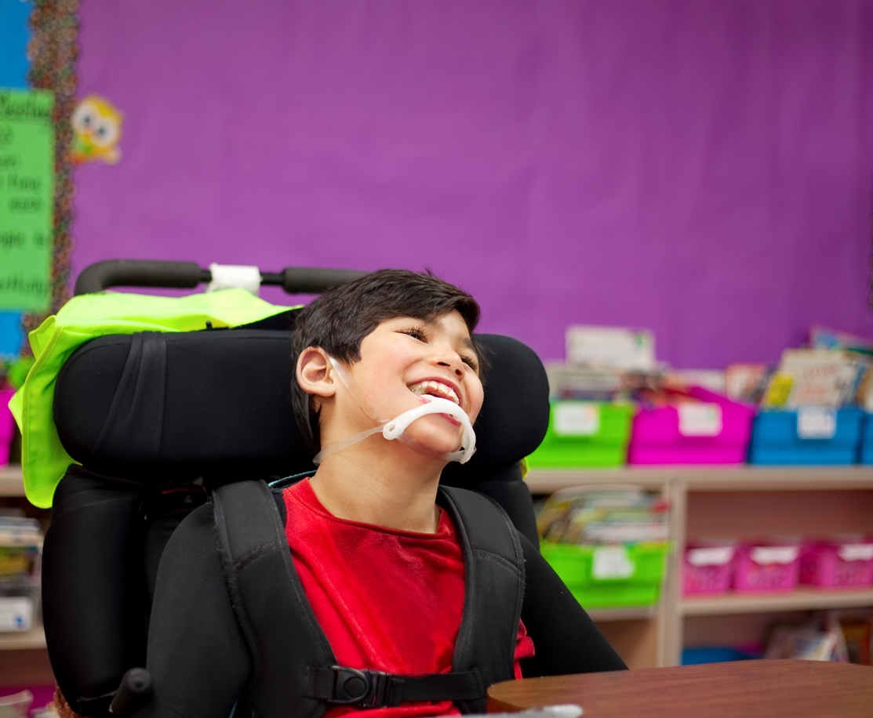
Image on page 30
Boy with disabilities in a wheelchair sitting at a desk in a classroom.

In their own words – experts

“There is a general lack of understanding of parents/teachers/school management about the potential of children with disabilities to learn.”

“There is an apathy of parents and of the education system that in itself contributes to the lack of access to school in the first place.”

“Access to assistive devices, and what device or platform is better for the children, depends on country and level of family or community income.”

“iOS is the best for features but is expensive in Indian conditions. So a cheaper iOS or an Android with more features is ideal.”

“There is a lack of assistive technology that would use children’s mother tongue for communication, and that makes these devices unusable for some children.”

Advantages of AT
AT experts were asked to select advantages of integrating accessibility features in mainstream technology.
- 69 reported that it was beneficial as parents and teachers do not have to look for specialized pieces of equipment.
- 61 felt that it is institutionally better as multiple people could be using the same piece of equipment.
- 62 indicated that it makes maintenance and repair easy and more manageable.
- 75 indicated that integrating accessibility features in mainstream technologies was cost-effective, because, as indicated by 71 AT experts, it makes communication easier as everyone uses the same source and same medium.
- 61 AT experts indicated that the integration of accessibility features to mainstream technology encourages collaborative working.
- 89 experts indicated that integration alone promotes mainstreaming and inclusion.
- 86 experts agreed that access to AT addresses problems commonly faced by students with disabilities in accessing the curriculum; 40 agreed that it helps membership and leadership in the learning community; 74 agreed that it enhances and promotes independence in reading, writing and research, while 81 said the use of AT provides equal and equitable access to content.
“Using assistive technology and devices enhances independence, and avoids learning helplessness. In the long run, students who become independent using assistive technologies, require less support from staff, which, in a way, reduces expenditure, as students acquire independent life skills.”

“While using assistive technology could address multiple issues in learning, it truly makes possible the access to same learning curriculum which is the essential first step towards equal opportunity.”

How to lower costs of AT
Experts were asked to describe some of the ways they thought the cost of AT could be lowered, and how tangible policies could be created to enable access to AT for students with disabilities.

They pointed to a number of ways, such as: government subsidies; laws to ensure that ATDs are not sold over a minimum price; government grants to manufacturers of AT so it can be sold for lower profits; mass production to raise competition among manufacturers; cost-sharing among various stakeholders; awareness-raising among educational institutions, manufacturers, government agencies and other stakeholders on universal design, inclusion and accessibility.

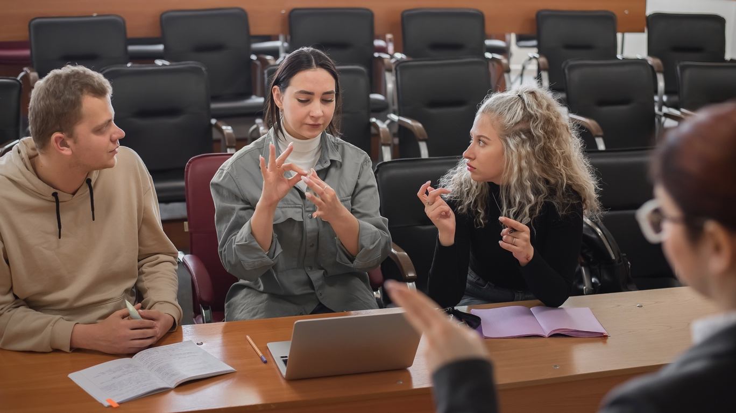
Image on page 32
A teacher and students communicate in sign language in a classroom.

In their own words – experts

“Accessibility features should be integrated with regular technologies right at the beginning as universal design.”

“It is essential that we continue to encourage and lobby mainstream technology providers to add and enhance accessibility features in mainstream technology, which also leads to cost reduction.”

“If we use devices that can be used both by students with disabilities and their non-disabled peers, the cost would come down automatically. But to do that, we need to have very strict laws for the development of any such technologies that they should be accessible and adhere to the standards of universal design.”

“People need to be open-minded and aware. For example, you could be spending thousands of dollars on a software, like Dragon Naturally Speaking, or you could simply use Talk Back or Microsoft’s dictation feature for free. But you need to be aware that these resources exist.”

Raising Awareness of AT
AT experts also noted that people often lacked the awareness of accessibility features on mainstream devices, and hence were not aware of how best to make them usable for students with disabilities.

AT experts emphasised that in order to make ATDs more readily available to students with disabilities, it was essential that parents and teachers were aware of existing low-cost technical solutions.

“Inclusive technologies must be accompanied by training on how to use them so teachers can teach their use to students with disabilities.”

“There are already good no-cost or low-cost solutions out there – but they are not yet well known. E.g. in the countries we work in, everyone refers to JAWS as THE screen-reading software, although NVDA is also a great solution. People need to be aware of them so they can quickly be made available for students, instead of waiting for a high-cost JAWS which can take time to be available.”

Policy and planning
- 86 AT experts indicated that it was important to follow an assessment process to find a good technical solution and appropriate plan to adapt it to changing needs.
- 72 indicated that AT should be integrated across all course work to facilitate its learning and use.
- 62 AT experts identified that there needed to be proper policy procedure and guidance or provision of AT by government authorities.
“Students who are involved in their education with innovation and development of technologies, should be guided to develop their technical projects adhering to inclusivity and accessibility for all. It would go a long way – it would mean more inclusive technologies, and more people who are thinking about inclusion, so we would have a generation which thinks about inclusion. It is also important that persons with disabilities are also involved in creating and developing assistive technologies and devices which would integrate the user prospective and more authenticity to any innovation.”

Conclusion
Experts with a diverse range of experience, from countries that are well developed in the use of AT to countries where the usage of AT is very limited, favoured platforms like iOS, Android, and Windows that have accessibility features like screen readers, captioning, and speak selection to name just a few.

They also stressed that minor, simple modifications to everyday items could even serve as AT. This is a strong reminder that technological inclusion begins when devices are designed with accessibility features from the outset. As Android says in its accessibility statement: “From the start, we build with accessibility in mind. We work together to learn how we use devices, what obstacles we might face and what our days look like when we have disabilities.” It also is a reminder that providing tools to students with visual, hearing and learning disabilities that enable them to function independently is not always an expensive affair. Not only is integration of accessibility features cost-effective for the users, it also means more business for the companies developing these technologies.

AT experts make strong recommendations such as lowering the cost of AT, integrating the use of AT in teacher preparation programs, integrating the use of AT across course work to enable students with disabilities to learn its use, and establishing proper policies for procurement of accessible technologies and platforms. This would enable AT to not only be more generally available, but also be available to the students who need them, while teachers would be more conscious of their use.

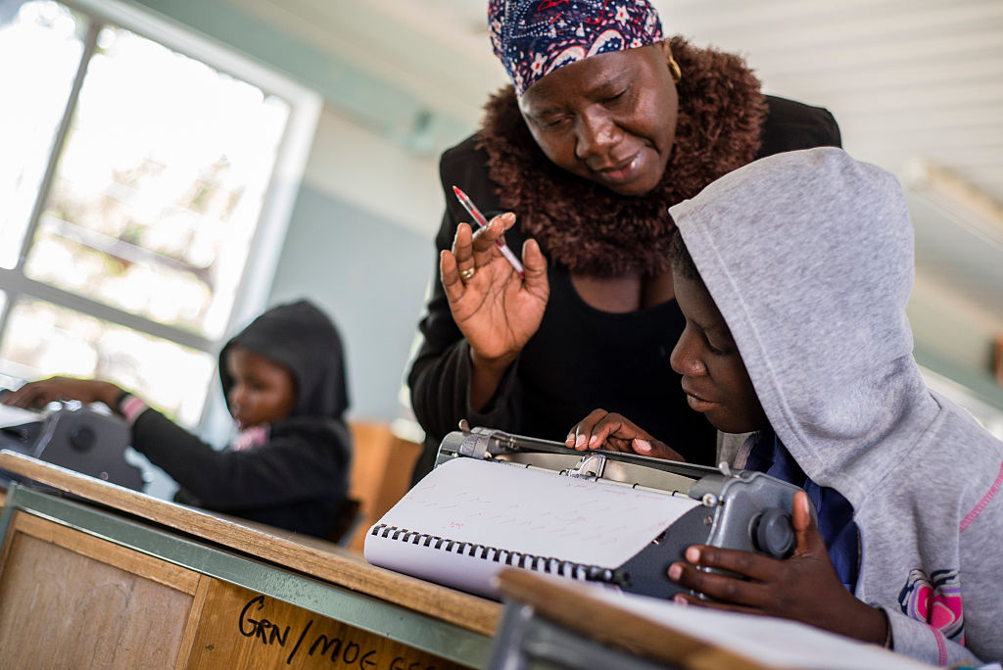
Image on page 35
A teacher helps a visually impaired learner to use a Braille typewriter during an English lesson at Eluwa Special School in Ongwediva, Namibia.

Conclusions and Recommendations

This research was primarily based on the understanding that while for most people technology makes things easier, for students with disabilities access to technology is an indispensable first step towards overcoming barriers to learning and living with independence. Through a combination of survey questions and interviews, the research endeavoured to suggest ways that the quality and provision of AT could be improved. It set out to find out what AT students and their teachers use, and how and why they find such technologies effective. The perspective of AT experts provided valuable insight into what AT meant in practice, what were the barriers to its use, its enabling factors, and how access and provision to AT could be improved. On the basis of 160 responses gathered from 39 countries, the following 12 recommendations can be made across three themes: developing assistive technologies, facilitating access, and improving training and awareness.

Developing Assistive Technologies
All three groups of respondents in the research felt that devices used in everyday life function well as AT when they are designed with integrated accessibility features. Even simple adjustments such as font size, text colour and style on a smart phone, computer or tablet can help students. A large proportion of AT experts working with children with different disabilities favoured iOS, Windows and Android platforms that had in-built accessibility features such as screen readers, captioning and guided access. Therefore one accessibility feature could be useful for more than one kind of disability, without necessarily offering a one-size-fits-all solution. Students with visual, hearing and learning disabilities, and their teachers, preferred using mainstream devices as it did not make the students feel different from their non-disabled peers, while teachers did not have to look for specific technical guidance or instructions as they were familiar with the students’ mainstream devices.

Recommendations on developing AT:
- Design mainstream or specialized technologies by integrating accessibility features for different needs of multiple users, such as image description, screen readers, zoom or magnification, captioning, restricted touch areas, eye tracking, among others.
- Design specialized technologies to function in multiple languages so they can also be used in a student’s mother tongue.
- Keep accessibility features at the forefront of development and design of mainstream technologies so AT is more readily available, cost-effective, and easy to use.
- Involve persons with disabilities and their organizations in creating and testing any technologies to include authentic user experience. This could also potentially lead to skill development and more employment opportunities for persons with disabilities.

Facilitating Access to Assistive Technologies
Teachers as well as students felt that the use of technology has led to a significantly improved level of teaching and learning, thereby empowering both students and their teachers.
Students said they feel and experience a sense of accomplishment at being able to perform the same academic task independently, similar to their non-disabled classmates.
Yet barriers restricting or inhibiting access to AT include availability of AT, high cost, lack of appropriate support, training, awareness and lack of accessible materials.
All three groups in our survey emphasised that access to education for students with these disabilities goes beyond access to AT. Provision of an AT alone does not guarantee accessibility – it has to be accompanied with accessible materials that can be used on the technology the students have.

These recommendations are designed to guide education systems and policy makers on how to improve access to AT:
- Create academic and learning materials in accessible formats that can be accessed on ATDs that students have and provide alternate modes of access such as simplified content, multiple accessible formats such as braille, audio, large print, and sign language, among others.
- Develop and implement policies on the procurement of AT and publishing learning and other materials in accessible formats.
- Introduce children with visual, hearing and learning disabilities to AT as soon as they need access to information.
- Reduce cost of AT by government subsidies, establishing a standard price for AT, grants to manufacturers of AT, mass production, cost-sharing, integrating mainstream technologies with accessibility and buying devices that can be used by multiple users.

Improve Training and Awareness
Each group of respondents felt that in order to make the experience of teaching and learning more rewarding for students and their teachers, and to provide a fully inclusive enabling learning environment, students and teachers need to have access to better training on the use of AT, accompanied by greater efforts to raise awareness of AT among stakeholders.

Their main recommendations were:
- Create policies that mandate provision of AT, the procurement of AT, lowering cost of AT, and the production of accessible learning materials.
- Follow a continuous assessment and evaluation process to determine appropriate assistive technology as per the needs of students, and ensure that the technology continues to be effective with the changing needs of the students.
- Set aside some time for students with visual, hearing and learning disabilities and their teachers for them to learn the use of assistive technologies by introducing course work on assistive technologies in teacher preparation programs and as part of the learning curriculum for students with visual, hearing and learning disabilities.
- Train students with visual and hearing impairment and learning disabilities, their parents, and teachers on the use of specialized technologies.
- Integrate learning on AT in teacher preparation programs, with trusted sources of information and networks to discuss effective and suitable AT.

“There are examples of countries that take their policies seriously and are against any discrimination on grounds of disability. This needs to happen everywhere if the promise of education for all is to be achieved.” - Gordon Brown, UN Special Envoy for Global Education.

Only then will students with disabilities be fully included in mainstream education systems and will SDG4 be achieved, allowing all children to have an equal chance of a genuinely good quality, inclusive education and the opportunity to pursue and rich and fulfilling life.

Appendices

Appendix 1

Definitions of disabilities

Visual Impairment
Visual impairment, or vision loss, is a condition in which partial or complete ability of the eyes to see is lost, and the impairment is persistent even with the use of eye-glasses, contact lenses, medication, or surgery. Visual impairment, in general, can mainly be divided in two broad categories, that is low or partial vision, or an absolute loss of eyesight, commonly known as blindness.

The classification of visual impairment differs across countries. WHO classifies visual impairment based on visual acuity (clarity of vision) or visual field (the area or distance from which visual information can be perceived). In its tenth revision of the International Statistical Classification of Diseases, Injuries and Causes, WHO defines low or partial vision with a visual acuity of less than 6/18 but equal to or better than 3/60, or a corresponding visual field loss to less than 20°, in the better eye with the best possible correction. Complete blindness is defined as visual acuity of less than 3/60, or a corresponding visual field loss to less than 10°, in the better eye with the best possible correction. It is also worth noting that the classification and definition of low and partial vision, can too, differ widely, based on the numerical or visual acuity standards held by the eye care professionals, or in national legal frameworks.

The American Foundation of the Blind (AFB) gives a more functional definition of low or partial vision and blindness. AFB defines low vision as the condition of an un-correctable vision loss that interferes with everyday activities and renders a person unable to perform their usual tasks with the amount of vision they have. Blindness is defined by AFB as a condition in which there is a complete lack of light and form perception.

A visual impairment, then, is certain to interfere with a student’s academic pursuits. The Individuals with Disabilities Education Act (IDEA) of the United States, defines visual impairment as an impairment that even with correction, adversely affects a child’s educational performance. Some of the challenges children with visual impairment may face include safely navigating around the classroom, conceptualizing objects, reading, writing, and using standard educational tools such as calculators and word processing software.

Hearing Impairment
Hearing impairment, or hearing loss, is diagnosed when a hearing test finds that a person is unable to hear 25 decibels (dB) in at least one ear. Hearing impairment or loss can affect one or both ears, and leads to difficulty in hearing conversational speech or loud sounds.

Hearing impairment can be divided in four categories based on severity, which is determined by the minimum sound that can be heard by the better ear. The classifications of hearing impairment are mild, moderate, severe or profound. People who have a mild hearing impairment can hear sounds between 25 and 40 dB. This renders them unable to hear soft voices and they are unable to follow conversations in noisy settings. People suffering from moderate hearing impairment can hear sounds between 40 and 70 db. People suffering this severity of hearing impairment cannot hear unless they use a hearing aid, and have trouble hearing soft or moderately loud sounds. People who have severe hearing impairment can hear sounds between 70 and 95 dB. They are unable to hear most noises and may depend on lip-reading and/or sign language, even with the use of a hearing aid. People who have a profound hearing loss can only hear sounds of 95 dB and over. They may hear only very loud sounds, and depend solely on lip-reading and/or sign language. Hearing aids are not effective at this stage.

However, it is worth noting that there remains a slight difference between hearing impairment and deafness. A hearing loss above 90 decibels is generally considered deafness, while that below 90 decibels is considered hearing impairment. Like visual impairment, hearing impairment or deafness are certain to interfere with a student’s academic pursuits.

IDEA defines deafness as a condition of impairment in hearing that is so severe that a child is unable to process linguistic or speech information through hearing, with or without amplification. This also means that a hearing aid would be insufficient to provide enough accommodation for a student to be able to succeed in a classroom. Challenges students with hearing impairment or hearing loss face mainly persist around communication. These may include difficulties in subjects of grammar, spelling, or vocabulary, taking notes while listening to lectures, participating in classroom discussions, listening to educational audio files or listening to the audio contents of such videos, presenting or answering oral reports or assessments, among others.

Learning Disabilities
The Learning Disabilities Association of Canada (LDA) defines learning disabilities as a “number of disorders that affect the acquisition, organization, retention, understanding or use of verbal or nonverbal information”, with these disorders affecting learning in an individual who may otherwise demonstrate at least average abilities essential for thinking and/or reasoning. It adds that, “learning disabilities result from impairments in one or more processes related to perceiving, thinking, remembering or learning”. The WHO defines learning disabilities as a state of arrested or incomplete development of mind. People with a learning disability have a significant impairment of intellectual, adaptive and social functioning. The IDEA defines learning disabilities as disorders in which one or more basic psychological processes in understanding or using written or spoken language result in an imperfect ability to listen, speak, write, read, think, spell, or perform mathematical calculations.

Two factors are common to all definitions: that they result in difficulties of perception, thinking and learning; and that they are not to be confused with other disabilities such as hearing impairment or deafness, visual impairment or blindness, motor disabilities, or behavioural disorders. Students with learning disabilities face a number of challenges in education, including reading, writing, spelling, reasoning, holding a pencil, recalling and/or organizing information if left to figure things out by themselves or if taught in conventional ways. Due to the range of challenges that students with learning disabilities can face, learning disabilities is accepted as an umbrella term for a number of specific learning disabilities, and can be divided into various categories based on the type of a more specific learning disability.

Types of Learning Disabilities

Auditory Processing Disorder (APD)
This form of learning disability affects the way sound travels through the ears, and is processed or interpreted by the brain. People with this kind of a learning disability find it impossible to distinguish one word from the other, even when the sound that they hear is loud and clear. Furthermore, they also find it difficult to identify the direction the sound is coming from or to block out any competing or interfering noises.

Dyscalculia
This affects the ability to understand numbers and learn to perform mathematical calculations. People with this form of learning disability struggle to comprehend maths symbols, perform calculations, memorize and organize numbers, tell the time, or simply count.

Dysgraphia
This affects a person’s ability to write and interferes with motor skills. It results in difficulties like illegible handwriting, inconsistent spacing, and poor special planning on paper, poor spelling, difficulties in writing compositions, and moreover, thinking and writing at the same time.

Dyslexia
This affects reading and related language-based processing skills. The severity of dyslexia can differ in each individual, but potentially affects reading fluency and comprehension, decoding, recalling, writing, spelling, and sometimes even speech. Dyslexia is also referred to as a Language-Based Learning Disability, and can exist along with other related disorders.

Language Processing Disorder (LPD)
LPD relates to difficulties in processing language. However, unlike APD, people suffering with LPD have difficulty in processing expressive language, either what they want to say or what others have to say to them. They may be able to hear well, but unable to understand the meaning of what’s being spoken, have a difficulty in expressing their thoughts in verbal form, or simply finding words for what they have to say. They may be able to draw and describe an object, but still be unable to think of a word for it.

Non-Verbal Learning Disabilities
This disorder causes difficulties between higher verbal skills and weaker motor, visual-spatial and social skills. People with this form of learning disability have difficulties understanding nonverbal cues like facial expressions or body language, and may have poor coordination.

Visual Perceptual/Visual Motor Deficit
This learning disability affects the interpretation of the information that is seen by the individual, or the ability to draw or copy. The disorder results in missing subtle differences in shapes or printed letters, losing place frequently, struggles with cutting, holding pencil too tightly, or poor eye-to-hand coordination.

Appendix 2

Definitions of Assistive Technology

AT for Visual Impairment
Students with visual impairment face challenges ranging from difficulties accessing the core curriculum, participation in curricular and co-curricular activities, lack of access to appropriate technology, shortage of books with accessible media, and improper school infrastructure (AFB, 2005; Jones, 2017). However, the proper use of AT allows students with visual impairment to independently access and gather and share information, helping them to overcome barriers to information and communication, and enabling them to independently and easily participate in the general curriculum (Presley and D'Andrea, 2008).

There are a number of ATDs that students with visual impairment may use in a classroom. These may be screen readers or magnifiers that can either read aloud or enlarge the information displayed on the computer screen (Kelly, 2009). Students with visual impairment, can, depending on accessibility, affordability and usability, use either mainstream or specialized technology (Sapp, 2007). These can be devices such as iPads, computers or audio devices, or braille notetaker, PAC Mate, etc. Experts on inclusion and AT for the visually impaired claim that mainstream technical products make for better assistive ATDs, providing a connection with a sighted world, helping sounder inclusive practice (Hong, 2012; Kamei-Hannan et al., 2012; Scott et al, 2013). For instance, the use of an iPad enhances inclusion in class by increasing visual attentiveness and communication (Campana and Ouimet, 2015).

AT for Hearing Impairment or Hearing Loss
The challenges that students with hearing impairment face in learning can be reduced by using AT, as AT reduces the gaps between the occurrence and detection of sounds (Lozano et al., 2007). The ATDs that students with hearing impairment are able to use vary from something as simple as captioning or sign language training, to more high-cost items such as hearing aids and cochlear implants. Classroom noise, continuous discussions, rapid change in discussion topics, and a number of people simultaneously engaged in discussions all act as barriers for students with hearing impairment and hinder their participation in student-teacher and student-student interaction (Luckner and Muir, 2001). AT for individuals with hearing impairment can play an essential role in their education in mainstream schools and help achieve effective inclusion.

AT that people with hearing impairment use can broadly be categorized in three main types: hearing AT, alerting devices, and communications supportive technology. Assistive hearing devices help with hearing or listening by enabling wearers to recognize sounds through enhancing the frequencies of sounds (Bankaitis, 2007). Hearing aids, cochlear implants, FM systems, infrared systems, and loop systems are some examples of this category of AT.

Alerting devices use the sound and visual amplification or vibration techniques to alert persons with hearing impairment that there may be a sound they need to respond to. Vibrotactile and signalling devices are examples of alerting tools.

Communication supportive technology helps oral or written communication, and can be further divided into three categories. These include telecommunication (cell phones, amplified and captioned telephones, pagers), closed captioning, and person-to-person and group communication activities (web cameras, computer assisted note-taking techniques, real time captioning and speech- or voice-to-text devices) (Hersh and Johnson, 2003). Persons with hearing impairment are likely to benefit most when they have access to mainstream technology. The iOS platform is a good example of communication supportive technology in telecommunication. While features such as Facetime video and iMessage provide a reliable means of communication through sign language and text messaging respectively, iOS devices can be connected with hearing aids and have customisable settings that can be adjusted to suit the needs of the user.

AT for Learning Disabilities
Although reading problems may vary, most students show slow and effortful word decoding skills (Lundberg 1995). While poor decoding skills means poor comprehension of textbooks and course reading materials, many persons with learning disabilities also have difficulties with basic writing skills, spelling and grammar, as well as higher-level skills, such as the planning, organization, and revision of a piece of work (Graham et al. 1998).

The use of appropriate ATDs by students with learning disabilities can enable them to cope better with or overcome their difficulties in reading and writing efficiently and independently. AT can improve the writing skills of students with learning disabilities (Batorowicz et al., 2012). Speech synthesis software like a screen reader (text-to-speech), or voice recognition software (speech-to-text), word processers, organizational software, etc. enable students with learning disabilities to progress with or complete their academic work, either by listening to the computer, organizing information, or dictating to the computer for written output.

Speech synthesis programs convert the text on the computer screen into a computerised speech and read aloud the digital text from the computer screen (Young and MacCormack, 2014). This kind of software can have a positive impact on decoding and word recognition, along with reading fluency and comprehension (Stodden et al., 2012).

Similarly, text can be entered in a computer either by typing directly in the speech synthesis program, or in another word processing program compatible with the speech synthesis program in use (Forgrave, 2002). Speech synthesis software offers the flexibility to students to read selected words, sentences, lines, or the entire text (Lundberg 1995), thereby enabling students with learning disabilities to read at their own pace, taking as much time as they require between reading one word, or line, or sentence from the next.

Voice recognition software or speech-to-text, as the name suggests, enables students to complete their written work by dictating to the computer, which then produces written output. This type of software enables students with learning disabilities to overcome the difficulties of typing or handwriting and enables them to compose written work that is longer, more complex, and has fewer errors.

Word processing programmes with features like spell checkers allow students to accomplish written tasks by compensating for some of the spelling errors that students with learning disabilities might make. It facilitates completion of work that is more organized and error-free (Hetzroni & Shrieber, 2004). At the same time, word prediction software, combined with speech synthesis programmes, is also effective for students with learning disabilities as they minimize the need to handwrite or type, and improves spelling accuracy and writing skills (Evmenova et al., 2010).

Organizational software enables students with learning disabilities to organize information and ideas through multiple webs or concept maps on a computer screen. This software is advantageous for students with learning disabilities who find it difficult to express their thoughts on paper, along with those individuals who require to see their ideas mapped out on paper (Young and MacCormack, 2014). It enables them to arrange their thoughts on a screen without having to worry about order, importance of ideas and categories, as the text can be easily manipulated.

Such software programs enable students to focus on appropriately communicating their ideas and helps to raise their self-esteem. In addition, there are other ATDs that students with learning disabilities find useful, such as “pentop” computers or smart pens. These are cheaper than many high-cost solutions and provide text-to-speech and other organizational functions, proving to be useful and effective reading aides (Schmitt et al., 2012).

Pentop computers also utilize instruction strategies such as providing auditory feedback during composition or maths work. Handheld computerized devices that provide feedback have been helpful for students with learning disabilities for essay composition and receptive note-taking and multiplication skills (Bouck et al., 2009A; Bouck et al., 2009B). For instance, pentop computers are able to provide reminders such as “don’t forget to carry” during multiplication questions (Doughty et al., 2013).

Appendix 3

Glossary of assistive technologies

Alerting Devices: Devices that use the sound and visual amplification or vibration techniques to alert persons with hearing impairment that there may be a sound they need to respond to. Some examples are vibrotactile and signalling devices.

Android: An operating system developed by Google that runs on mobile devices like tablet computers and smart phones.

Apple Mac: ‘Mac’ is a nickname for series of Macintosh computers made by Apple.

Assistive Hearing Devices: Devices that provide a sense of sound to persons with hearing impairment by enhancing the frequency of sounds. Cochlear implants, hearing aids, FM systems, infrared systems, and loop systems are a few examples.

Audio devices: Any electronic device that can receive and process audio signals without a video. One example is a tape recorder.

Brailler: A mechanical device for writing or typing braille.

Captioning: A text version of speech and other sounds that can be provided on a screen.

Chrome Devices: Devices that run or operate on Google’s operating system.

Clicker 8: A literacy software that provides writing and speech feedback, a talking spell checker and word prediction.

Communication Access Real-time Translation (CART): Instant translation of the spoken word into text using a stenotype machine, notebook computer and realtime software.

Computer Assisted Note Taking: A technique that helps people with hearing impairment participate in meetings and lectures with hearing people, as a note taker uses a computer with a word processing software to type notes that are displayed on a wall projector or a computer screen.

Digital braille: A medium that converts digital content on screen into braille that can be accessed using electronic braille displays. Some examples are braille notetaker, PAC Mate and Orbit Reader.

.epub: An open standard format for E-books created by the International Digital Publishing Forum.

Eye gaze or Eye-Tracking Technology: An electronic device that enables control of a computer or a tablet by looking at words or commands on a video screen.

iOS: Apple’s mobile operating system that runs on Apple’s iPhones, iPads and other Apple devices.

iPad: A touch screen tablet made by Apple.

KNFB or OneStep Reader: An application that enables people with visual impairment, dyslexia and other print disabilities to click a picture of a printed page that can be read aloud by a screen reader or be displayed digitally in braille.

Magnifier: A device or software that is used for magnification or enlargement of text on a paper or on a computer screen.

Optical Character Recognition (OCR): A technique that by using a software, extracts data from printed or written text from a scanned document or an image file and converts it in a format that can be read by a screen-reader software.

Pentop computer/Smart Pens or Pen Readers: Digital pens that provide audio feedback and are equipped with ball-point ink cartridge, a microphone to record audio, a speaker for playback, a small OLED display, an infra-red camera, and internal flash memory that captures handwritten notes, audio and drawings. This portable, pocket-size device is used as an assistive technology for students with learning disabilities and has an in-built dictionary that is used to display the definition of a word as the pen-nib is passed across the word. One example is the Livescribe Pen.

Seeing AI Application: An artificial Intelligence application developed by Microsoft for iOS, that uses the device camera to identify and describe people and objects for people with visual impairment. A similar application available on both iOS and Android is the Envision AI application.

Speech Synthesis or Screen Reader (Text-To-Speech): An assistive technology software, primarily used by people with visual impairment that converts text and other visual elements on a screen into speech. Some screen readers also have the capability to convert visual elements on screen in braille. Job Access with Speech (JAWS), NonVisual Desktop Access (NVDA), Voice Over, Talkback and Narrator are some popular examples.

Voice Recognition or Speech-to-Text: A software that enables the translation of speech or spoken language into text as the user speaks into a microphone. Speech or voice recognition can also be used to operate a device or perform commands. Dragon Naturally Speaking, Okay Google, Hey Siri, Cortana are a few examples.

Web camera or webcam: A video camera that feeds or streams an image or video in real time to or through a computer network.

Word prediction software: Word prediction programs prompt the user with a list of likely word choices based on words previously typed. Some word prediction software automatically collects new words as they are used and considers a person's common vocabulary when predicting words in the future.

Word Processing Software: Software that enables the user to write or type text in a document or create or edit a document, and provide options to copy, delete and format the text or even insert elements such as images in the same document. Microsoft Word is one such example of a Word Processing software.

Zoom: Audio and video chat software.

Appendix 4

Abbreviations and Terminology

AFB American Foundation of the Blind
APA American Psychiatric Association
APD Auditory Processing Disorder
AT Assistive Technology
ATDs Assistive Technology Devices
CRC Convention on the Rights of the Child
CRPD Convention on the Rights of Persons with Disabilities
IDEA Individuals with Disabilities Education Act
LPD Language Processing Disorder
NGO Non Governmental Organization
OCR Optical Character Recognition
SDGs Sustainable Development Goals
UN United Nations
UNICEF United Nations Children’s Fund
UNESCO United Nations Educational, Scientific and Cultural Organization
UK United Kingdom
US United States of America
WHO World Health Organization

For the purposes of this research, visual impairment referred to any degree of vision or sight loss, hearing impairment referred to any degree of loss in hearing, and learning disability referred to disorders that affect the acquisition, organization, retention, understanding or use of verbal or nonverbal information.

Appendix 5

Survey Questionnaire

Please choose from the following, which category of respondents you belong to
- Student with a disability
- Teacher who has taught or teaches student(s) with disabilities in a mainstream classroom
- Independent or NGO personnel working with assistive technology for students with disabilities

Questionnaire for Students with Disabilities

- What is your disability? *
Choose only one option.
- Visual Impairment or Blindness
- Deaf or hard of hearing/hearing impaired
- Learning Disability
- Other:

- In what country do you go to school? *
Write your response:

- What is your education level *
Choose only one option
- Primary School
- Secondary School
- College or University
- Other:

- What academic challenges do you face, or previously faced in your school environment due to your disability? *

Choose all that apply.
- Lack of assistive devices
- Lack of training or knowledge on using the assistive devices available
- Lack of knowledge of my teachers on using the assistive technology available
- Inappropriate assistive devices
- Presence of assistive devices but lack of materials to be used with those assistive devices (e.g. you have a computer with a screen reader, but not enough books in accessible formats)
- Classroom noise, such as continuous discussion or rapid changing discussions that make it hard for you to differentiate and participate
- Other:

- Could you name some of the assistive technologies (software and hardware) that you use for your academics? *

Choose all that apply.
- iOS devices
- Android devices
- Screen readers
- Magnifiers
- Audio devices such as a tape recorder
- Digital Braille e.g. braille notetaker and packmate
- Assistive Hearing Devices e.g. Hearing aids, Cochlear implants, F.M systems, Infrared system, and loop system
- Alerting tools such as vibrotactile and signalling devices
- Cell phones, amplified and captioned telephones, pagers
- Web cameras
- Computer assisted note taking
- Real time captioning
- Speech or Voice to text software
- Organizational software
- Word processing programmes
- Word prediction combined with voice recognition software
- Pentop computer or smart pens
- Other:

- What are the features about the technologies you use that you like the best and why? *
Write your response:
- What features do you feel are lacking in the technology you use and could be more effective for your studies? *
Write your response:
- How did you procure the technology you use? *
Choose all that apply.
- Were bought by my school on my request
- Were bought by my school due to school policy
- Were provided by my local government on my request
- Were provided by my local government due to local la
- Were purchased by my family
- Other:

- Do you feel completely independent in using or accessing these technologies? *
Choose only one option.
- Yes, I feel completely independent and almost never or only rarely have to ask for assistance from others
- No, I do not feel independent at all and have to constantly ask for assistance
- Yes, I feel independent, but often have to ask for assistance as the devices are somewhat inaccessible
- Other:

- How do you think the use of these technologies can further facilitate independent learning? *
Write your response:
- How useful has technology been for your learning? *
where 1 indicates not useful at all and 5 indicates very useful.
- 1
- 2
- 3
- 4
- 5

- Is there anything that would allow you to use your technology more effectively and efficiently? Please explain: *
Write your response:

- Does the technology you use, make you feel different from your non-disabled peers in class? *
Choose only one option.
- Not at all. Because of the technology, I am independent, and can do everything else as my non-disabled classmates
- Yes. I am seen as different and am always separated from my classmates because I use a special equipment
- Don’t know
- Other:

- If yes, what alternative do you suggest can be used for meeting your academic needs in a mainstream classroom?
Write your response:

Final Questions (asked to students, teachers and experts)

- Is there anything else you would like to add?
Write your response:

- Are you interested in being contacted further or in future for this research by Theirworld?
Choose only one option.
- Yes
- No

If so, please leave your name and email below:
- Name:
- E-mail:

Please type “Yes” in the space provided:
I give Theirworld permission to use the information submitted for research purposes and contact me about this project or relevant initiatives.

Questionnaire for Teachers of Students with Disabilities

- What is the disability of the student/students you teach? *
Please check all that apply.
- Visual Impairment or Blindness
- Deaf or hard of hearing/hearing impaired
- Learning Disability
- Other:

- What subjects do you teach and for which grade level? Write your response

- What country do you teach in?* Write your response

- Could you name some of the assistive technologies, that you use to teach your students with disabilities? *
Choose all that apply.
- iOS devices
- Android devices
- Screen readers
- Magnifiers
- Audio devices such as a tape recorder
- Digital Braille e.g. braille notetaker and packmate
- Assistive Hearing Devices e.g. Hearing aids, Cochlear implants, F.M systems, Infrared system, and loop system
- Alerting tools such as vibrotactile and signalling devices
- Cell phones, amplified and captioned telephones, pagers
- Web cameras
- Computer assisted note taking
- Real time captioning
- Speech or Voice to text software or devices
- Organizational software
- Word processing programmes
- Word prediction combined with voice recognition software
- Pentop computer or smart pens
- Other:

- What do you like best about these technologies and why? *
Write your response:

- How did you procure these technologies? *
Choose all that apply.
- Were bought by my school on my/my student's request
- Were bought by my school due to school policy
- Were provided by my local government on my/ my student's request
- Were provided by my local government due to local law
- Were purchased by the student themselves
- Other:

- Do you need support in using these technologies? *
Choose only one option.
- I feel completely independent and almost never or only rarely have to ask for assistance from others
- I do not feel independent at all and frequently ask for assistance
- Yes, I feel independent, but sometimes ask for assistance
- Other:

- If feeling dependent, how are you dependent on others and how do you think this can be changed? If feeling independent, how do you think the use of these technologies has made you more independent than you would have been if you were not using these technologies? *
Write your response:

- Are your students with disabilities happy with the use of technology you are using? *
Choose only one option.
- Yes, as the students with disabilities are able to do most academic things independently
- No. It has not made much of a difference
- Technology has made a difference, but it is not yet optimal for my teaching
- Other:

- How much has technology improved your teaching of children with disabilities? *

where 1 indicates not useful at all and 5 indicates very useful.
- 1
- 2
- 3
- 4
- 5

- Out of all the technologies you use, which one do you think is the most effective and why?
Write your response:

Questionnaire for Assistive Technology Experts

- What in your opinion, is assistive technology for children with disabilities best described as: *
Choose all that apply.
- Specialized equipment or software that allow children with disabilities to study, play and perform other activities on a par with their non-disabled peers
- Simple modifications in daily items we use can be assistive technology for children with disabilities
- Regular devices we use in everyday life can be assistive devices for children with disabilities if they are integrated with some accessibility features
- Other:

- Which of the following disabilities do you work on? *
Choose all that apply.
- Children with visual impairment/blindness
- Children with hearing impairment or who are deaf or hard of hearing
- Children with learning disabilities
- Other:

- Which country do you work in? *

- Which of the following do you think are the most useful for children with disabilities in accessing education. *
Choose all that apply.
- iOS devices come with screen reader for visually impaired, captioning for the deaf, and other features for people with learning disabilities
- Android devices come with screen reader for visually impaired, captioning for the deaf, and other features for people with learning disabilities
- Windows devices come with many enhancements features to enhance accessibility
- Other:

- What are the most significant barriers for children with disabilities in accessing assistive technology? *
Choose all that apply.
- Lack of assistive devices
- Lack of teacher knowledge and training in using assistive devices
- Lack of parental knowledge and training in using assistive devices
- Inappropriate assistive devices
- Lack of materials to be used with assistive devices (e.g. you have a computer with a screen reader, but not enough books in accessible formats)
- Lack of knowledge for specialized features in mainstream technology
- Specialized devices are expensive and unaffordable
- People do not think using assistive devices are going to make any difference
- Too many different technologies for different tasks
- Specialized platforms are inaccessible
- Other:

- What approaches and sources are most important to the learning and use of assistive technology by children with disabilities, their teachers, and their parents? *
Choose all that apply.
- Assessment process – Finding a good solution and planning how to adapt it to changing needs
- Trusted sources of information – Organizations where people have a lived experience of a technology
- Accessible training materials
- Teacher preparation programs
- Integration of technology across all course work
- Ability to take technology back home
- Provision of technology by government authority
- Networks around technology – Forums where people gather and talk about what they find best in any assistive technology
- Other:

- What are the biggest advantages have you seen to having assistive features integrated in the same piece of equipment that everyone uses, rather than a separate piece of technology?*
Choose all that apply.
- Parents and teachers do not have to look for specialized pieces of equipment
- Promotes mainstreaming and inclusion
- Is cost-effective
- Makes maintenance and repair easy and more manageable
- Makes communication easier as everyone uses the same source and same medium
- Provides for collaborative working
- Institutionally better as multiple people could be using the same piece of equipment
- Other:

- Do you agree with the following statement?
From an expert perspective, children with disabilities should be introduced to assistive technology as soon as they need access to information. *
Choose one option.
- Yes
- No

- What are the biggest issues with learning or accessing academics that assistive technologies or devices address for children with disabilities? *
Choose all that apply.
- Issues in accessing the same learning curriculum
- Membership and leadership in learning community
- Independence in reading, writing, and research
- Equal and equitable access to content
- Customization of content
- Portability of content
- Other:

- What are the biggest barriers that exist for students with disabilities that prevents full inclusion in education. *
Choose all that apply.
- Lack of strict procurement policies for assistive technologies
- Lack of clear accessibility guidelines
- No accessible versions of learning platforms
- No Monitoring of the content for accessibility put on visual learning environments
- Lax laws that do not mandate all public learning platforms be accessible
- Other:

- It is often felt that accessing or getting hold of assistive technologies is an expensive affair, and even more so in developing countries. Are there ways the cost of inclusive technologies could be lowered? *
Write your response:

- As of now, where do you see the future of assistive technologies going? *
Write your response:

Bibliography

Ainscow, M. and Miles, S. (2008). Making Education for All inclusive: where next? Prospects, 38(1), pp.15-34.

American Foundation for the Blind (AFB). (2005). Educating Students with Visual Impairments for Inclusion in Society: A Paper On The Inclusion Of Students With Visual Impairments Retrieved from: http://www.afb.org/info/teachers/inclusive-education/35 [Accessed 10th April 2018].

Batorowicz, B., Missiuna, C. A., & Pollock, N. A. (2012). Technology supporting written productivity in children with learning disabilities: A critical review. Canadian Journal of Occupational Therapy, 79(4), 211-­‐224. Doi:10.2182/cjot.2012.79.4.3

Bouck, E. C., Bassette, L., Taber-­‐Doughty, T., Flanagan, S. M., & Szwed, K. (2009A). Pentop computers as tools for teaching multiplication to students with mild intellectual disabilities.Education and Training in Developmental Disabilities, 44, 367–380.

Bouck, E. & Flanagan, S. (2009B). Assistive technology and mathematics: What is there and where can we go in special education. Journal of Special Education Technology, 24, 24-­‐30.

Bankaitis, A. U. (2007). Hearing assistive technology. In Valente, M., Hosford-Dunn, H., & Roeser, J. R. (Eds.), Audiology Treatment (pp. 400-417). NY:
Thieme Medical Publishers.

Blecker, N.S. and Boakes, N.J. (2010). Creating a learning environment for all children: Are teachers able and willing? International Journal of Inclusive Education, 14(5), pp.435-447.

Campana, L.V. and Ouimet, D.A. (2015). iStimulation: Apple iPad Use with Children Who Are Visually Impaired, Including Those with Multiple Disabilities. Journal of Visual Impairment and Blindness, 109(1), pp.67-72.

Chong, P.W. and J. Graham, L. (2017). Discourses, decisions, designs: ‘special’ education policy-making in New South Wales, Scotland, Finland and Malaysia. Compare: A Journal of Comparative and International Education, 47(4), pp.598-615.

Courtad, Carrie Anna & Bouck, Emily. (2013). Assistive Technology for Students with Learning Disabilities. 10.1108/S0270-4013(2013)0000025011.

Doughty, T., Bouck, E., Bassette, L., Szwed, K. & Flanagan, S. (2013). Spelling on the fly: Investigating a pentop computer to improve the spelling skills of three elementary students with disabilities. Assistive Technology, 25, 166-­‐175. Doi:10.1080/10400435.2012.743491

Evmenova, A., Graff, H., Jerome, M., & Behrmann, M. (2010). Word prediction programs with phonetic spelling support: Performance comparisons and impact on journal writing for students with writing difficulties. Learning Disabilities Research & Practice, 25(4), 170–182. Doi:10.1111/j.1540-­‐ 5826.2010.00315.x

De Witte, Luc, Steel, Emily, Gupta, Shivani, Ramos, Vinicius Delgado, & Roentgen, Uta. (2018). Assistive technology provision: Towards an international framework for assuring availability and accessibility of affordable high-quality assistive technology. Disability and Rehabilitation: Assistive Technology, 13(5), 467-472.

Forgrave, K. E. (2002). Assistive Technology: Empowering Students with Learning Disabilities. The Clearing House: A Journal of Educational Strategies, Issues and Ideas, 75(3), 122-126. Doi:10.1080/00098650209599250

Florian, L. (2008). Inclusion: special or inclusive education: future trends. British Journal of Special Education, 35(4), pp.202-208.

Graham, S., K. R. Harris, C. MacArthur, and S. Schwartz. 1998. Writing instruction: Use of technology. In Learning about learning disabilities, 2d ed., edited by B. Wong, 410-14. Bumrnaby, BC: Academic.

Graeme Douglas, Mike McLinden, Steve McCall, Sue Pavey, Jean Ware & Ann Marie Farrell (2011) Access to print literacy for children and young people with visual impairment: findings from a review of literature, European Journal of Special Needs Education, 26:1, 25-38, DOI: 10.1080/08856257.2011.543543

Hersh, A. M., & Johnson, A. M. (2003).Assistive technology for the hearing impaired, deaf and deaf blind. London: Springer – Verlag.

Hetzroni, O. E., & Shrieber, B. (2004). Word processing as an assistive technology tool for enhancing academic outcomes of students with writing disabilities in the general classroom.Journal of Learning Disabilities, 37, 143-­‐154. Doi:10.1177/0022221940403

Haug, P. (2017). Understanding inclusive education: ideals and reality. Scandinavian Journal of Disability Research, 19(3), pp.206-217. DOI: 10.1080/15017419.2016.1224778

Hong, S. (2012). An alternative option to dedicated braille notetakers for people with visual impairments: Universal technology for better access. Journal of Visual Impairment and Blindness, 106(10), p.650-655.

House of Representatives, Congress. (). H.R. 4278 (EH) – Improving Access to Assistive Technology for Individuals with Disabilities Act of 2004. [Government]. U.S. Government Publishing Office. https://www.govinfo.gov/app/details/BILLS-108hr4278eh

Kamei-Hannan, C., Howe, J., Herrera, R.R. and Erin, J.N. (2012). Perceptions of teachers of students with visual impairments regarding assistive technology: A follow-up study to a university course. Journal of visual impairment and blindness, 106(10), pp.666-678.

Kelly, S. M. (2009). Use of assistive technology by students with visual impairments: Findings from a national survey. Journal of Visual Impairment and Blindness, 103, pp. 470-480.

Lundberg, I. 1995. The computer as a tool of remediation in the education of students with reading disabilities: A theory-based approach. Learning Disabilities Quarterly 18 (2): 89-99.

Lozano, H., Hernaez, L., Navas, E., Gonzalez, F. J., &Idigoras, I. (2007). “Non- Speech” sounds classification for people with hearing disabilities. In G. Eizmendi et al. (Eds.) Challenges for Assistive Technology (pp. 276-280). BG, Netherlands: IOS Press.

Luckner, J., & Muir, S. (2001). Successful students who are deaf in general education settings. American Annals of the Deaf, 146, 435–445.

Presley, I. and D'Andrea, F.M. (2008). Assistive technology for students who are blind or visually impaired: a guide to assessment, New York: AFB Press.

Ramchand, B. and Dummugudem. (2014): "Inclusion Education as Solution to Barriers of CWSN and Answer for their Success." International Journal of Humanities and Social Science Invention vol.3 no. 8.

Sapp, W. (2007). My school day online: applying universal design principles to the development of a fully accessible online scheduling tool for students with visual impairments. Journal of Visual Impairment and Blindness, 101(5), pp. 301–307.

Scott, S., Hunter, J., Kendall, N., McAtee, R. and Melton, R. (2013). IOS – Worthy of the hype as assistive technology for visual impairments? A phenomenological study of IOS device use by individuals with visual impairments, ProQuest Dissertations and Theses. Tennessee State University.

Schmitt, A., McCallum, E., Hennessey, J., Lovelace, T., & Hawkins, R. (2012). Use of reading pen assistive technology to accommodate post-­‐secondary students with reading disabilities. Assistive Technology, 24, 229-­‐239. doi:10.1080/10400435.2012.659956

Stinson, M. (2018-10-25). Importance of Technology for Education of Deaf Students. In Evidence-Based Practices in Deaf Education. : Oxford University Press.

Stodden, R. A., Roberts, K. D., Takahishi, K., Park, H. J., & Stodden, N. J. (2012). The use of text-­‐to-­‐speech software to improve reading skills of high school struggling readers.Procedia Computer Science, 14, 359-­‐362. doi:10.1016/j.procs.2012.10.041

UN General Assembly. (1989). The United Nations Convention on the Rights of the Child, United Nations, Treaty Series, vol. 1577, Available at: http://www.unicef.org.uk/Documents/Publication-pdfs/UNCRC_PRESS200910web.pdf [Accessed 10th April 2018].

UN (2006). United Nations Convention on the Rights of Persons with Disabilities. Division for Social Policy and Development: Available at: https://www.un.org/development/desa/disabilities/convention-on-the-rights-of-persons-with-disabilities/convention-on-the-rights-of-persons-with-disabilities-2.htmlgt

UNESCO (2017). A guide for ensuring inclusion and equity in education. Paris: UNESCO. Available at: http://unesdoc.unesco.org/images/0024/002482/248254e.pdf [Accessed: 10th April 2018].

UNESCO (1994). The Salamanca Statement and Framework for action on special needs education: adopted by the World Conference on Special Needs Education; Access and Quality.

UNESCO (2000). Education for All Movement:

UN (2015). Sustainable Development Goals: 17 Goals to transform our world: Available at: https://www.un.org/sustainabledevelopment/education/ [Accessed: 10th April 2018].

UNESCO (2015). Education 2030: Incheon Declaration and Framework for Action. Paris: UNESCO. Available at: http://unesdoc.unesco.org/images/0024/002456/245656e.pdf [Accessed: 10th April 2018].

UNESCO (2008). The EFA global monitoring report. Education for all by 2015. Will we make it? Paris: Available at: http://unesdoc.unesco.org/images/0015/001548/154820e.pdf [Accessed: 10th April 2018].

UNICEF (2022). Global report on assistive technology. A joint UNICEF-WHO report. Available at: https://www.unicef.org/reports/global-report-assistive-technology

World Health Organisation (WHO) (2011). World report on disability. Geneva: WHO. Available at: http://www.who.int/disabilities/world_report/2011/en/ [Accessed: 10th April 2018].

