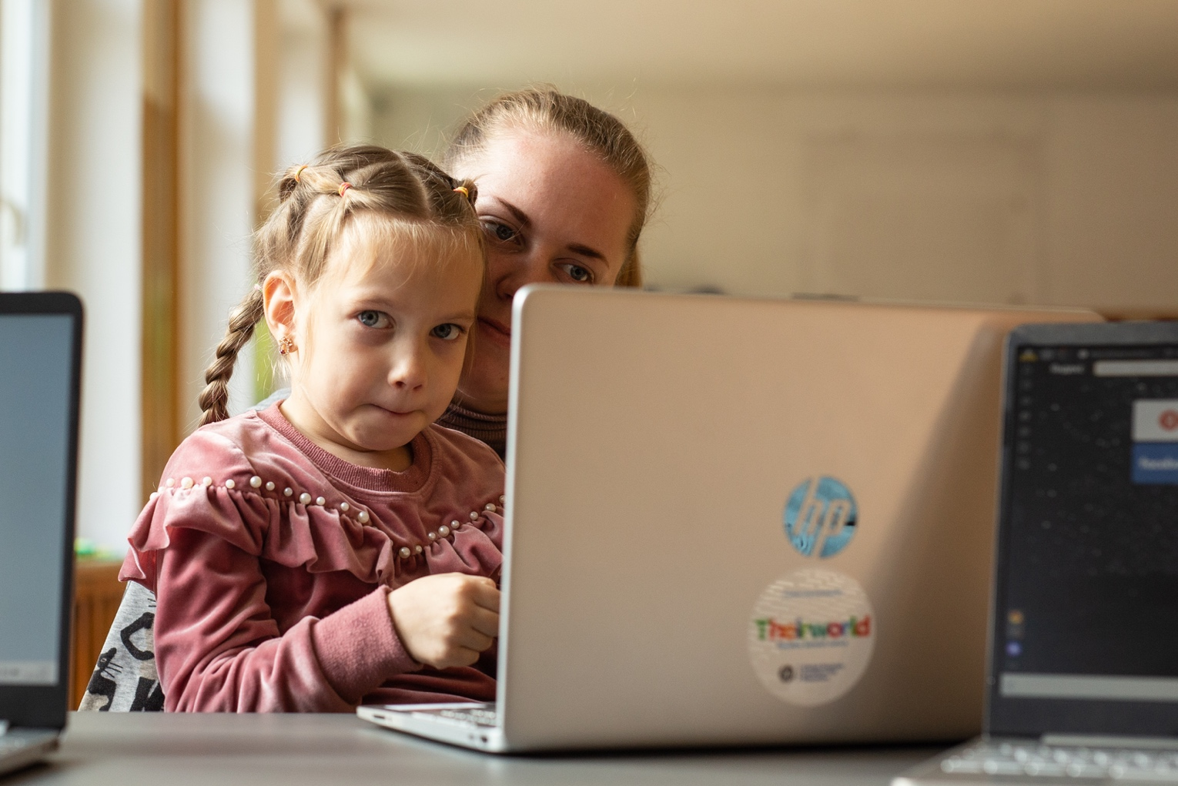

Resilience and Ingenuity:

Young Ukrainians’ Experiences
of Emergency Education

Front cover image
A young girl completes her school work on a laptop.
Credit© Theirworld / Robert Wilk

Authors: Veronika Skorobogatko and Juliette Bonnepart
OPORA Foundation
February 2023

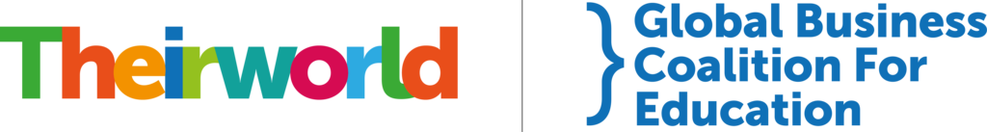

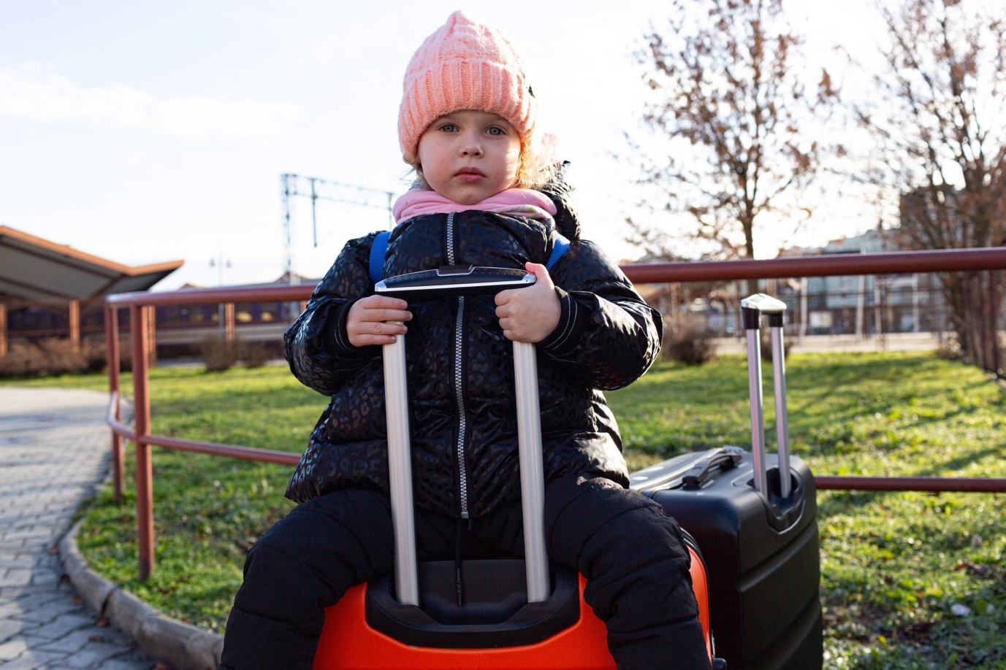

Image on page 2
A Ukrainian girl sits on a suitcase whilst feeing to Poland.
Credit© UNICEF / Mateusz Reklajtis

Introduction

February 24 marks the one-year anniversary of the full-scale Russian invasion of Ukraine. Amid widespread destruction and loss of life, schools and education have been severely damaged.

The Ministry of Education of Ukraine has estimated that by the end of January 2023, 3,098 educational institutions have been damaged by bombing and shelling, including 438 destroyed. The majority of those are located in the eastern and southern parts of Ukraine, but Kyiv and regions around the capital have also suffered badly.

As of January 2023, more than eight million Ukrainians have become refugees in other countries and more than five million children inside and outside the country have had their education disrupted, according to the United Nations.

A core part of Theirworld’s mission is to find ways to support and improve the quantity and quality of education in conflicts and emergencies. Education is often overlooked by the humanitarian community when disaster strikes, but parents and children very often say it is the first thing they want restored once they have re-established a basic level of security.

We therefore decided to investigate how Ukrainian children and youths have responded to the immense disruption to their lives and their education, and what their experiences reveal about education in emergencies more broadly.

Interviews for this qualitative report were carried out with mothers, school children and university students in Ukraine, the Netherlands and the UK by the OPORA Foundation, which is based in the Netherlands and provides evidence-based policy, research and operational solutions for and regarding displaced people.

Interviews were conducted with:
- four Ukrainian mothers and their children who have stayed in Kyiv and the Kyiv region;
- a Ukrainian teacher who moved to the Rotterdam region of the Netherlands;
- two Ukrainian mothers who moved to the Netherlands with their children (five combined in total, aged five to 17) - living in Amsterdam and near Den Bosch;
- two Ukrainian teenagers of high school age, both from the west of Ukraine and now living in the Netherlands, one in Rotterdam and the other in Almere, near Amsterdam;
- three Ukrainian university students - two in the Netherlands, one in the UK;
- a Ukrainian architect living in Rotterdam;
- two Ukrainian professionals working for the non-governmental organisation Smart Osvita.
The names of children and some mothers quoted in the report have been changed at their request.
Part one of the report looks at how individuals and families have coped with adversity; part two looks at how Ukrainian students and young people have organised to help their counterparts, while part three looks at how civil society organisations have responded to fill gaps in education. Interviews were conducted with mothers rather than men in the family due to ease of contact and communication.

The report’s findings portray a picture of great resourcefulness, resilience and ingenuity, with digital and hybrid solutions high among the coping mechanisms for students, their families and teachers.

The findings raise possible opportunities for charitable and philanthropic organisations to further assist young Ukrainians, including: supporting Ukrainian Houses or organisations helping Ukrainian students settle in a new country; providing digital resources and capacity.

However, young Ukrainians responses carry warnings about young people’s vulnerabilities and the necessity for the international community and nations hosting displaced people to remain vigilant to their needs.

Theirworld and the Global Business Coalition for Education’s work to support the education of refugee and displaced Ukrainian children is made possible thanks to the generous support of players of the National Postcode Lotteries, HP Inc., and Microsoft.

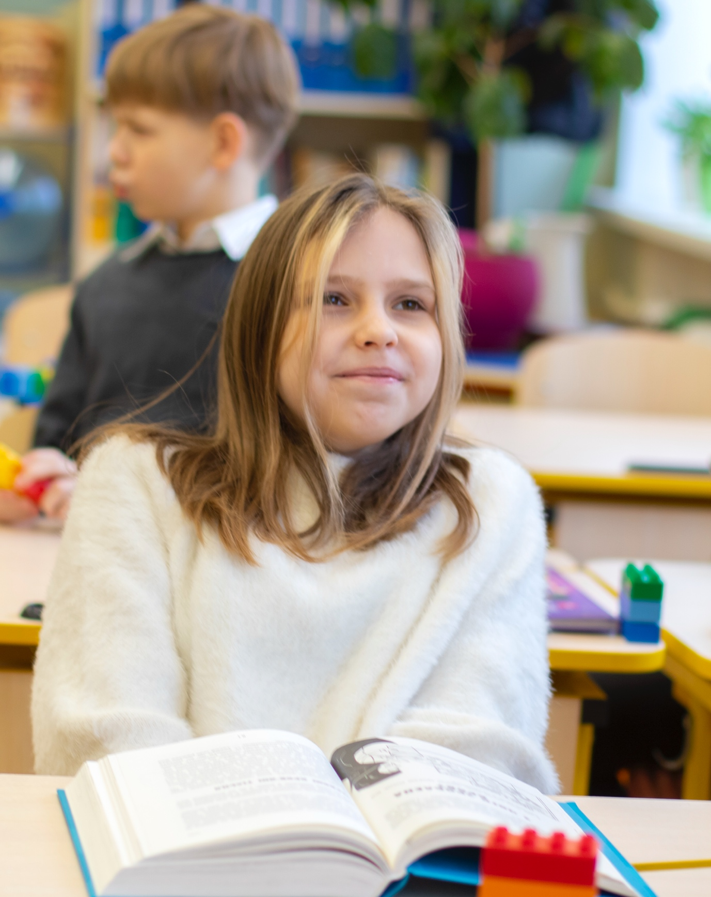Image on page 5
A Ukrainian girl participates in her lessons in Kyiv.
Credit© Theirworld / Oleg Salinko

Part 1

Learning to adapt

Attending school in-person or learning from home

Ukrainian schools closed when the full-scale Russian invasion started, meaning that tuition moved online. A partial re-opening of schools began with the new school year in September 2022, with yet more schools opening in January 2023.

Safety remains the priority, so the option of studying online remains in place in the majority of schools, while schools that don’t have access to bomb shelters or are located close to Russia or Belarus, or near military frontlines, kept all their tuition online.

Parents interviewed for this report supported in-person classes for their children at primary school, as it helped them study better and regain some sense of normalcy, while Katya, an eight-year-old from Kyiv, said:

“I like going to school, it is fun. After not being there for almost the entire year, I got very excited and nervous this January on the first day back.”

The war has forced structural changes on almost every school, which have designated areas converted into shelters, where children are directed during air-raid alarms. Some use this time and space to continue lessons, some just to wait and hide.

Older pupils are more likely to follow a hybrid learning system – mixing in-person attendance with learning remotely from home, especially because there is often not enough room or adequate conditions for everyone in damaged school buildings.

Dmytro, 14, from the Kyiv region, said that as his family lives quite far from school, they decided that he and his younger brother would continue with online classes. Although they don’t like spending so much time in front of the laptop, they became used to it during lockdown and the first months of the war, and always try their hardest to be active on the calls.

Until recently, distance education was also the only option for Mark, 15, from Kyiv, whose apartment building and school were damaged by bombing at the very beginning of the war. For the first six months he and his family stayed in another village in a shelter, until the new school year began in September. Neither his home nor school are yet fully repaired, but his home is good enough to live in, and he can attend school for a few hours a day and do the rest of his lessons at home.

The confict has also damaged his social network, and he wishes he could see his friends more often:

“Our classes were mixed up as some people left or decided to continue only online, new ones joined. I don’t have that many friends anymore.”

The conflict has forced everyone involved in education to adapt – parents, pupils, teachers and school staff. On top of having to reschedule classes around online and offline classes, there have since October 2022 been frequent blackouts and electricity shortages to deal with after Russia began targeting sources of power.

Schools have been forced to rely on generators and large numbers of power banks, while teachers have had to acquire new skills. As Maria, the head of a primary school in the Kyiv region and mother of three, said:

“Previously, we would provide training on medical first aid, now it’s common to put a question at the job interview for our prospective teachers - do you know how to start a generator? Now everyone has to do that.”

Taking things in their own hands and stepping out of their comfort zone

The interviews indicated that school children are prepared to go to great lengths and show great bravery in order to continue their learning digitally, or just to charge mobile devices for themselves and their families.

Oleksiy is only eight years old but has been through so much in the past year. He talks about his life with such a calm voice, as if things were utterly normal. However, his family had to hide in the basement of their house in the Kyiv region in February and March of 2022. Nowadays, the electricity and the internet still regularly go down, but he has found a solution.

“We don’t have generators, but usually we are okay. Sometimes, I can go to charge my devices at friend’s place as they have a generator or go to the ‘Point of Invincibility’.”

A network of Points of Invincibility government-built help stations across Ukraine became operational in November 2022. They provide safety, stability and warmth in the event of an emergency power outage, and provide Internet and power for mobile devices.

Halyna Tytysh, one of the founders of education non-governmental
Organization Smart Osvita, shared stories of children’s determination to continue following their online lessons even in dangerous zones.

“One 12-year-old boy, living in occupied territory, would ride his bike past dangerous roadblocks to have better connection, while others would connect in supermarkets,” she recalled.

In other cases collected by Halyna and her team, as well as those seen on the news, children of different school ages have been flexible and creative in finding opportunities to study. Some go to electronics shops during a blackout. Three boys in an unoccupied zone of Kharkiv built a shelter in a smokehouse on the top of a hill where the Internet was more reliable.

Some children are ready to seek learning opportunities beyond their curriculum, especially as teaching from their schools may be sporadic.

“I sometimes do an extra search on YouTube on the topics from chemistry and biology that were not explained well. We have extra maths, English and German lessons - those are separate from school,” said Dmytro.
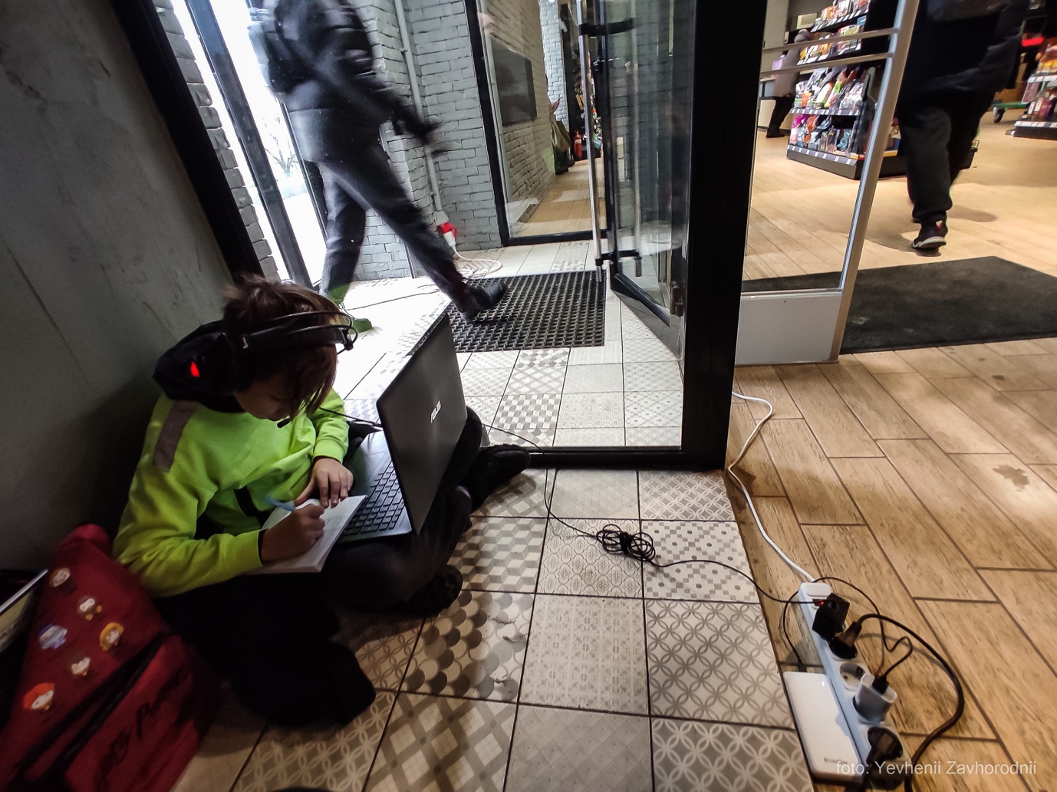

Image on page 9
Boy uses electricity and WiFi at a supermarket in Kyiv to do his homework. Credit© Eugene Zavgorodniy

The value of extracurricular activities and hobbies

All parents interviewed said school was a calming factor for their children, helping distract them from the war and the constant flow of grim news. Children who have stayed in Ukraine said they didn’t talk a lot about the war at school and didn’t have time to watch the news.

They had different perceptions of school – younger ones loved their school life, while older ones saw it more as a necessity – but all expressed excitement about their hobbies: basketball training and games, learning drawing techniques from online videos or attending art classes after school.

Dmytro, the 14-year-old from Kyiv, said: “Before the war, we didn’t have as much [basketball] training as in the last seven to eight months.”

Katya, said she had recently done her largest ever painting, in A2 format.

Continuing sports or other hobbies has helped them maintain a psychological balance, and helped their resilience in very tough times.

Many have not had access to psychological help within school, and sports and hobbies can make up for that. One mother quoted her son’s basketball coach as saying:

“Basketball is the best therapy.”

Displaced Ukrainian children and students leading a double educational life

Arriving in a new country is difficult and disruptive to school-age children. Olga, a mother of two from Dnipro, said:

“In the first few months in the Netherlands we had to live in three shelters, which was not the best experience. The other thee months we stayed in an apartment in Amsterdam Noord, then another three months in another place.”

Tetyana arrived with her four children after fleeing their home city Bucha in the Kyiv region.

“In the Netherlands we were hosted by a few families, living in the north of the country, then at the seaside, and then moved to the southern region of Brabant.”

Once settled, displaced Ukrainian children have had to integrate into new educational systems in the Netherlands and other EU countries, but many have decided to attend their host country school in the day and take extra Ukrainian classes in the evenings or weekends. They feel strongly motivated to stay connected with their national education system and their culture, even though it means extra work.

In the Netherlands, displaced children are appointed to an international class or a separate Ukrainian class, or in some cases to Dutch classes. They first receive intensive Dutch language lessons and then other school subjects also in Dutch. Some take quickly to a new language but others are less enthusiastic.

Most families and youth interviewed had kept up some contact with educational services in Ukraine. Younger ones simply didn’t want to lose touch with their home culture and language, while older students tended to want to gain the qualifications they would need to resume studying once it was safe enough to return home.

All said that going to school during the day and doing online classes in the evening was tiring. But Tetyana said:

“I offered them to stop [Ukrainian school] but they decided to continue. Moreover, the Ukrainian teachers are understanding of the situation and try to be reasonable with the homework. It helps that my 10-year-old is so used to doing everything on an iPad now.”

Two mothers and a 17-year-old girl said the motivation for maintaining educational contact with Ukraine was to finish their studies, receive their high school certificate and apply for a university degree programme either at home or in the Netherlands.

Tetyana said: “My 16-year-old is finishing her 11th grade online at a specialised distance learning school in Kyiv.

“She has to study herself, master topics and pass assignments, but she likes the flexible schedule. At the end of the school year she will have a ‘multi-test’ to enter a Ukrainian university - hopefully there will be locations to do the test in the Netherlands.”

Olga, a mother of two from Dnipro, said:

“Diana is now 16 and when we arrived in the Netherlands she decided to continue Ukrainian school in a form of non-residency - just to study at home and then pass exams at the end of the year. She really wants to finish her 11th grade and get the school certificate. Though said she wouldn’t apply for university this year – she doesn’t quite know what she wants, but is sure she doesn’t like to stay at school longer than this year.”

Those sentiments were echoed by Alina, aged 17, from Ivano-Frankivsk, who graduated from her Ukrainian high school last year while in the Netherlands. She was clear that she wouldn’t like to continue her school education in the Netherlands.

Preferring to apply for a university programme now, she found a few psychology and management programmes at Dutch universities, went back to Ukraine to collect all her certificates, had them translated and then quickly took the IELTS (International English Language Testing System) exams so she could apply.

She wasn’t accepted by Dutch universities, but after that initial disappointment, bounced back and showed considerable motivation and independence.

She explained: “It is difficult here [in the Netherlands] - expensive education and no one seems to be interested in you applying and won’t help and explain what to do. I didn’t search further and thought of having a gap, but at my temporary job I was doing graphic design and liked it a lot, so I want to expand my knowledge in the area and get a degree.

“So, I started looking for such a programme in Poland - it is cheaper there, closer to Ukraine, and the university is willing to help, both a bit financially and with the application, even in Ukrainian. The courses will be in Polish, so I am starting an intensive language course now, four times a week, and moving to Poland already in March to prepare more.”

Another example of determination and resourcefulness is Marianna, aged 17 from Ternopil, who is finishing her Ukrainian schooling online to receive her diploma in the spring of 2023. Meanwhile, she is also studying at a Dutch school and intensively learning the Dutch language as she has decided to apply for a university programme in the Netherlands. This is a major effort given that she came to the Netherlands just 10 months ago.

She said: “I would like to study communications, or business, or logistics here. At the same time, I really like the programme on international relations at a Ukrainian university and will apply there as well. I am ready to do both programmes - in person in the Netherlands and distance part-time in Ukraine.”

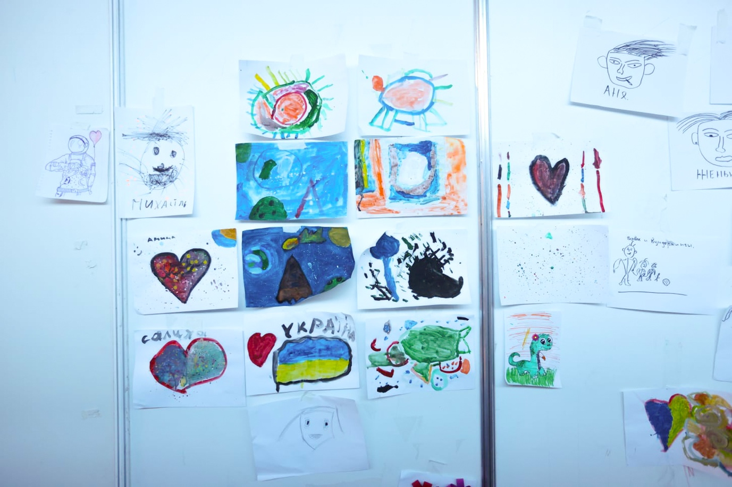
Image on page 13
Drawings made by Ukrainian children at a refugee centre in Moldova.
Credit© Education Cannot Wait

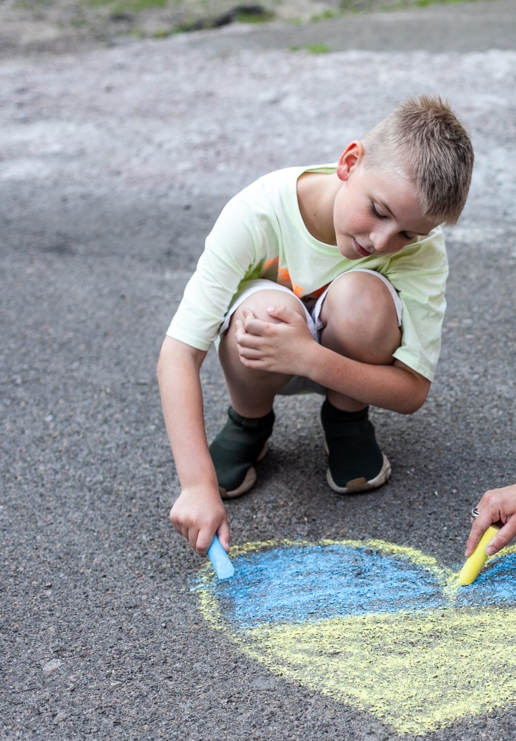
Image on page 14
A young boy draws a Ukrainian ﬂag on the asphalt with coloured chalks.
Credit© UNICEF / Antonina Latayko

Part 2

Young Ukrainians organising to help fellow Ukrainians

The report’s authors talked to teenagers in the Netherlands organising social events for other Ukrainian teenagers; student-led movements in the Netherlands and the UK helping people back home, and an educational programme organised by young Ukrainian professionals for Ukrainian children in Ukraine and in the Netherlands.

Teenager party committee in Rotterdam

The Ukrainian House in Rotterdam was opened by the city authorities early in the conflict to give Ukrainians displaced by war a hub with information about finances, childcare and education, as well as somewhere to meet and a space for children to play.

Initially its activities for children focussed on younger age groups, leaving teenagers feeling there was little there for them. Four displaced Ukrainian teenagers therefore decided to form a voluntary committee to organise parties for 16- to 18-year-olds.

The coordinator of the Ukrainian House and other adults supervise them, but the children are in charge of organising the parties, which help young Ukrainians socialise, find new friends and settle into their new environment. Given a small budget by Ukrainian House, they are responsible for buying food, drinks and decorations, making playlists and hiring lights. Usually 60-70 teenagers attend with most guests coming from Rotterdam but sometimes around a third travelling from The Hague.
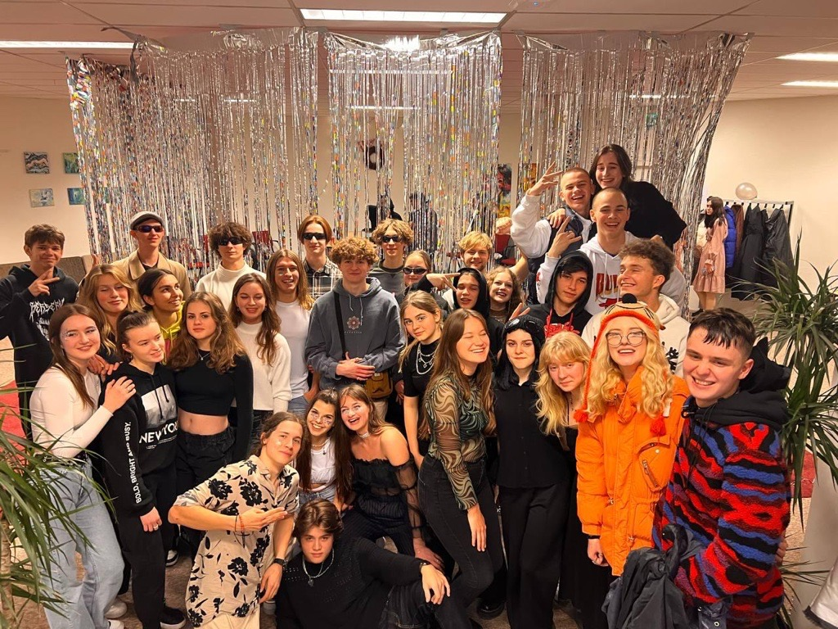

Image on page 16
A party organised by a teenager party committee
Credit© Ukraine House Rotterdam

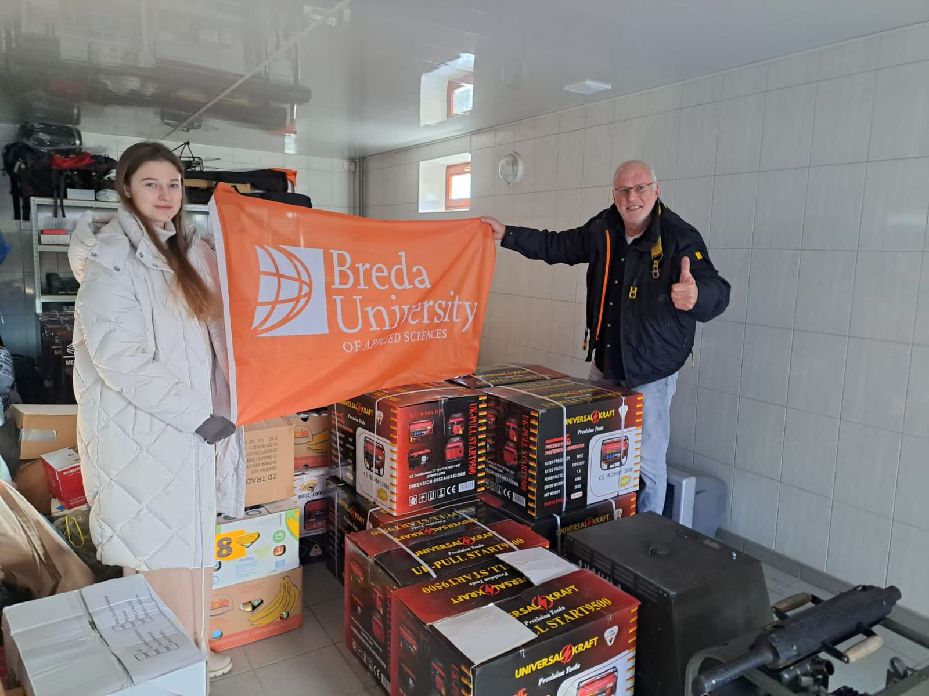

Image on page 16
Yana, 20, with the generators she helped send to Ukraine.
Credit© Yana Kyrylyuk

Marianna, 17, one of the organisers, has been helping at the Ukrainian House since April 2022. She used to organise parties in her home city of Ternopil, so quickly saw an opportunity for teenagers in the Netherlands to connect.

She said: “We create these parties specially for Ukrainian teenagers. We have people from various Ukrainian cities - Mariupol, Kharkiv, Lviv, etc. These parties helped many of them to connect, to find new friends and for some even form a romantic couple.”

Leading this initiative gives the teenagers a sense of responsibility but also some of the sense of freedom they would have enjoyed if their lives had continued as normal in Ukraine.

Ukrainian students organising humanitarian aid and fund-raising for Ukrainians

Olena moved to Glasgow in mid-2022, right after graduating in Ukraine, to do a Masters in International Law and Security. With help from the university, she has organised events to raise funds for people in Ukraine and to raise awareness in the UK about the conflict.

“We are the first who have arrived, so we can help those that will choose to come,” said Olena, from Odesa.

Her hope is that this network can provide guidance to Ukrainians planning to come to the UK who might need help with visas and documentation, which she said presented her with many difficulties.

Glasgow University is covering the tuition fees for 20 Ukrainian students per year, and Olena plans to apply for this, as life in the UK is very expensive. She considers herself lucky as she was able to study abroad, and speaks very positively about her experience.

Yana, 20, studies in the Netherlands. When the war broke out, her first response was to find a way to help Ukraine. With two other students from the University of Applied Sciences in Breda, she decided to set up a foundation to help send funds and equipment to Ukraine. However, the process was too long and complicated so with the university’s help they organised a movie night which ended up becoming an assignment for students who were studying facility management. The university then agreed to award credits to the team of students in charge of organising the charity event, meaning that organising for
other Ukrainians had a directly positive effect on their education.

Yana explains that she learned a lot about setting up a website, opening a bank account, marketing strategies and finding volunteers, while also improving her Dutch.

A lecturer and his friends decided to raise funds to send six generators to Ukraine, so he asked Yana to help him with all the transport and logistics. In December she and her family in Ukraine hosted the lecturer and his friends, as the generators, canned food, power banks and clothes arrived.

When back in the Netherlands they organised a conference at the university and the local newspaper wrote an article about their efforts.

“Motivation is not the right word. It is not that I have to do it, it’s just natural,” explained Yana.

Anna, a 22-year-old from Kyiv who is studying for a Masters degree in Amsterdam, set up a charity to send humanitarian aid back home.

She said: “We are our own little heroes in a country full of heroes.”

When the war broke out she was already studying at Leiden University. She organised a march in front of the Russian embassy. However, watching the news all day long was too much to handle, and she soon started volunteering in Amsterdam for the first Ukrainians who arrived. Then she started setting up a collection of humanitarian aid at the university.

At that point it became a full-time job that kept her mind busy – something that all interviewees said was very important for their mental balance. She and a few other students decided to set up an NGO to do this, sending at least 20 tons of Young Ukrainians’ Experiences of Emergency Education 17 humanitarian aid. With their partner organisation, Fastlane, she has travelled a lot as a translator for displaced Ukrainian people on their way to the Netherlands.

Delivering generators and other forms of humanitarian aid helps people access education as power is provided to schools and families can devote more time to education once other basic needs are met.

An educational programme led by young Ukrainian professionals for Ukrainian children

Back in Ukraine, children and teenagers were used to having a variety of extracurricular activities. One of the mothers interviewed mentioned that her 13-year-old son had enjoyed football, computer programming, graphic design and theatre as additional classes. Now that he lives in the Netherlands he has so far been unable to continue any of these activities.

Oksana is a young architect living in the Netherlands who left her career to become a coordinator at the Ukrainian House in Rotterdam, focusing on displaced Ukrainian teenagers. She and other Ukrainian professional architects and urbanists started a Saturday programme called a House for Home at Het Nieuwe Instituut, a prominent cultural centre in Rotterdam, running from February until the end of April 2023, offering courses on architecture and urbanism.

She believes that all teenagers have a difficult time finding out who they want to be and that self-expression is even more troublesome for displaced children. The project aims to give them a space in which to express themselves, improve their self-esteem and to process trauma better. A psychologist is on hand to give advice to tutors, who are experienced in teaching or tutoring children. After their courses conclude they will be able to exhibit their work publicly in the Het Nieuwe Instituut.

“Because of the war, the process of growing up has been put in the background, this is to give them the full attention they deserve,” said Oksana.

Over the last few months, Oksana has seen teenagers falling into unhealthy activities, such as using drugs. She thinks that migrant shelters are a very difficult place to live for a teenager. Moreover, these children mostly go to a Dutch school during the day and continue their Ukrainian school during the evenings, which, added to the stresses of difficult living environments - especially for those in shelters - can lead some teenagers to want to reject education altogether. This program gives them a place to come on a Saturday and space to create but also learn outside their school curriculums.

Demand for the courses was high, even from children not living in Rotterdam, and Oksana hopes that other municipalities in the Netherlands will be inspired by the project to help displaced teenagers across the rest of the country.

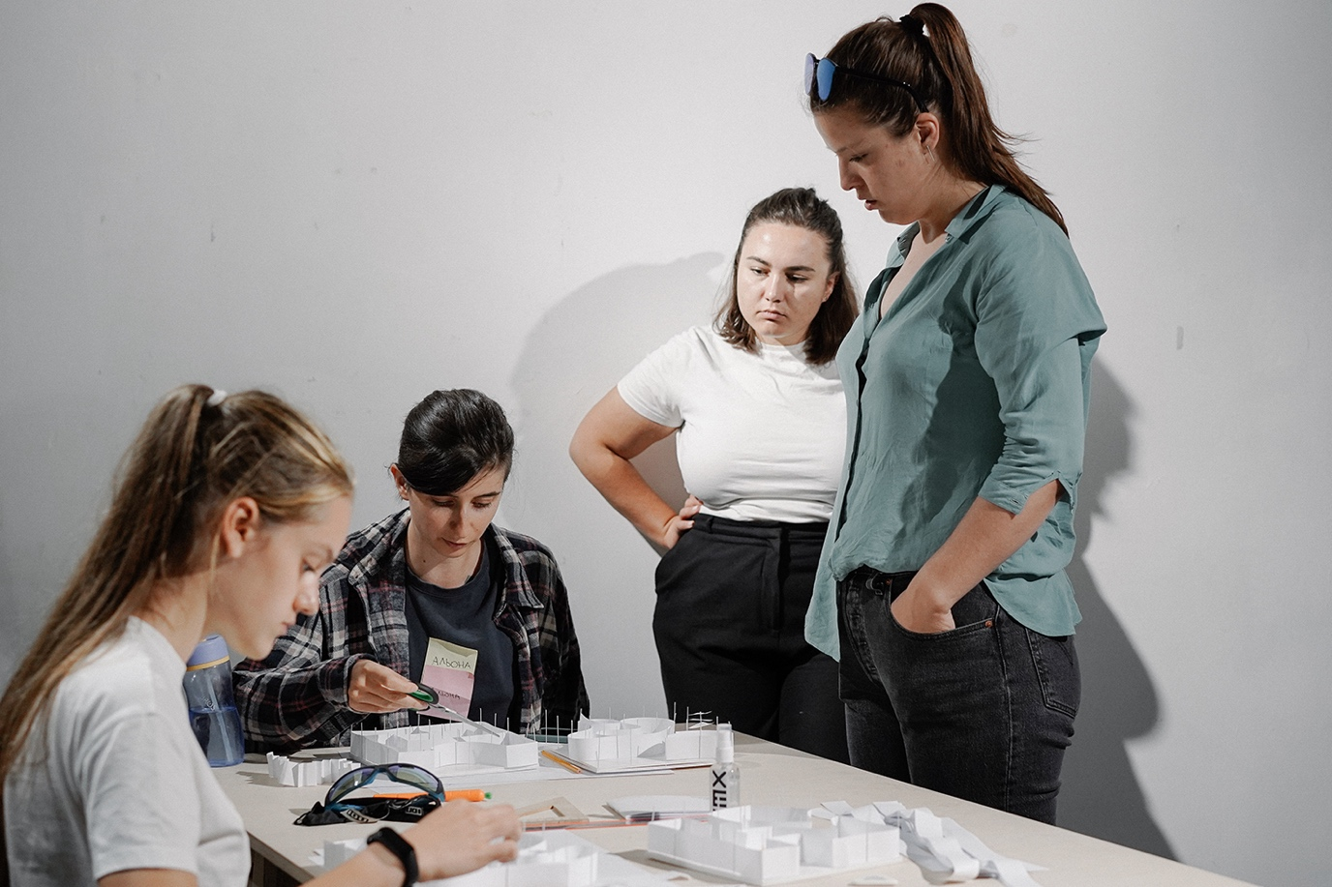
Image on page 20
Ukrainian teenagers take part in a Saturday programme.
Credit© A House for Home

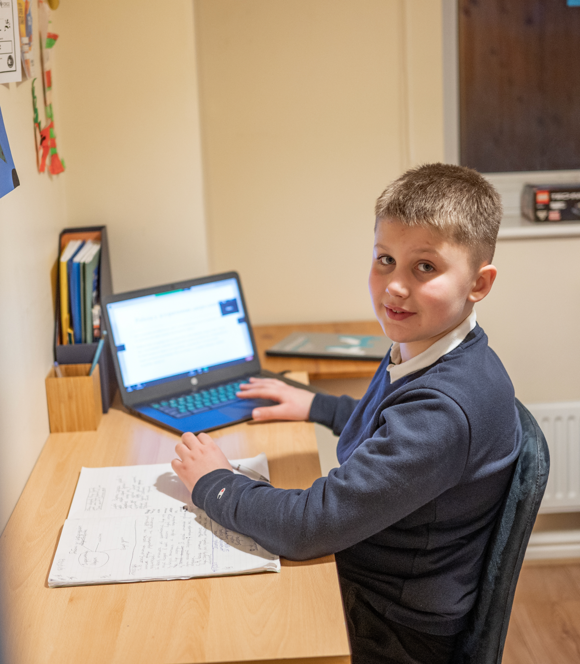
Image on page 21
A Ukrainian boy participates in Smart Osvita’s online lessons. Credit© Theirworld / Phil Wilkinson

Part 3

Digital initiatives enabling access to education
Digital projects have been crucial for young Ukrainians and provide a useful example for responding to future conflicts and emergencies. Ukraine’s Minister of Education Serhiy Shkarlet said that more than two million Ukrainian school students have continued their education online, while almost one million are following a hybrid form, as of November 2022. Programmes have been provided by a combination of resources from the ministry, the private and charitable sectors.

The trend for online learning, as in many other countries, began during the pandemic with a few specialised schools creating platforms for remote education with a gamified approach, and, the Unicorn School, a learning platform which operates under license from the ministry.

After the war broke out, online classes and platforms were expanded and developed to allow children to continue their education. Often they have complemented the educational system and filled in gaps in provision. Although most schools have been able to switch from offline to online teaching, not all have the resources, the electricity and infrastructure to do so.

The Ministry of Education has partnered with a few organisations to create special platforms for students and teachers to facilitate the educational process during the war. Two good examples are: Osvitanow.org – an informational platform created in a partnership between the Ministry of Education, UNICEF and Osvitoria Media that guides and links parents and teachers; and the distance education platform All-Ukrainian E-school, which contains a library of educational materials for students in grades 5 to 11.

Those efforts have been assisted by projects providing computing devices and software, such as the $30 million partnership Digital Equity for Ukraine, coordinated by the Global Business Coalition for Education with HP, Microsoft, the Ukrainian government and local NGOs.

Smart Osvita (Smart Education) has introduced projects helping children outside Ukraine access education when they have lost contact with their school. Stay with Ukraine maintains and develops children’s knowledge of the Ukrainian language, history and literature to help with their integration when they return home. It is used by hundreds of Ukrainian children currently living in the UK. To assist internally displaced children, Smart Osvita created the Catch-up Classes programme in the summer of 2022, online and also in person in Lviv. More than 100 teachers were connected to tutor students in maths, Ukrainian and English.

Halyna Tytysh, head of Smart Osvita, said that “digitalisation is a big success story but also a problem for schools”.

The main issues are a shortage of laptops or hardware for teachers and students and problems with electricity or outages. The Smart Osvita team was also surprised to find that teachers still need help developing their digital skills.

To address these challenges, the team is implementing more tools and working on new programmes:

- Planning a new platform for kids who have gaps in their studies
- Creating essay writing courses - for both teachers and students
- Launching audio classes for grades 8-11 in history, Ukrainian language & literature
- Providing trainings on formative assessment
- Trainings on psychological support and resilience for teachers

They have also introduced English-speaking meetings to allow children to learn and hear about something completely different from a diverse range of people, including an astronaut, yoga teachers, film directors, writers and TV presenters.

These volunteers are from all over the world. Sometimes more than 100 children connect to a session. A Japanese volunteer has a regular puppet show that four-year-olds love.

“We feel the support from everywhere and this helps us to feel like we are not alone”, said Olena, who leads the initiative and herself has three children and is internally displaced in central Ukraine.

More than 2,070 children have joined 73 different lessons, with the most common age group being 10-13. Although Olena is pleased with this number she is eager to attract even more children, especially when she recalls how one mother thanked her personally.

“She said that there were bombs not far from their bomb shelter and her sons did not hear them because they were in a lesson.”

Oak National Academy

Oak National Academy is an independent public body that supports teachers in the UK by developing classroom materials following the English national curriculum. All the lesson plans are based on expert resources that are independent, optional, adaptable, free and available online.

When the UK started receiving young people from Ukraine it set up a plan to translate these teaching methods into Ukrainian and Russian. So far 10,000 lessons have been translated, and the aim is to provide all displaced Ukrainian children with tools that they and their teachers can use to help them integrate into the English educational system.

Conclusions

Here are some lessons about education in emergencies that can be drawn from the thoughts and experiences of Ukrainian school children, university students, parents and young professionals.

- Ukrainian teenagers should be included in as many projects as
possible. They have demonstrated great resilience but that should not be taken for granted. They need guidance - to know where to put their energies (the urban design programme and the party committee are good examples of this).

- Ukrainian students who were living abroad when war broke
out have concentrated on providing humanitarian assistance
to Ukrainians in Ukraine. But they are also eager to assist new
Ukrainian student arrivals, even though at times they experience
financial uncertainty about their own degrees and feel that
universities could offer more assistance.

- Digital projects and initiatives have been key tools to maintaining access to education. The way they have been used so enthusiastically shows how much young Ukrainians want to connect with home and continue learning despite everything they have endured. They also show how resilient Ukrainian teachers and families are in helping children stay connected with learning opportunities.

- Hobbies and sports for some young people in Ukraine have been a form of therapy. Their readiness to keep up their hobbies suggests that this is a useful way for them to cope with the stress and move forward, especially as there is rarely any professional psychological support available.

- Despite the dire circumstances of war, some Ukrainian students have seized opportunities and matured very quickly. They are showing their creativity to recognise new possibilities and realise some of their dreams, as well as broaden their horizons and acquire new skills.

- Ukrainian children understand their situation and are ready to work hard, even if they don’t always feel motivated.

- The experiences of Ukrainian students abroad shows that “education” is broader than just what is learned in class. Through contributing to the relief effort, young Ukrainians are therefore learning skills and knowledge way beyond a traditional education, such as logistics, project planning and facilities management.

- Learning unexpected things might shape their lives differently and give them a more comprehensive view of how the world works and what their future interests and potential may be.

- The interviews raised possible opportunities for charitable organisations to further assist young Ukrainians, including: supporting Ukrainian Houses or organisations helping Ukrainian students settle in a new country; providing digital resources and capacity.

Image on page 27
Teenagers with donated laptops from the Digital Equity for Ukraine partnership. Credit© Theirworld / Robert Wilk

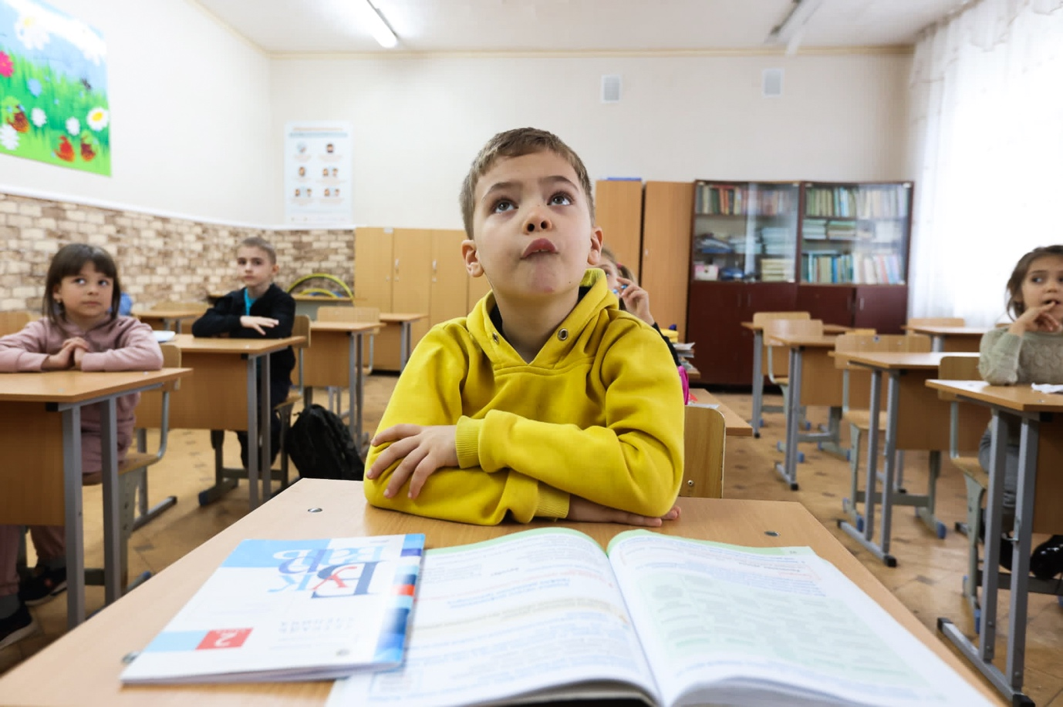
Backcover image
A Ukrainian boy listens to his teacher in Moldova.
Credit© Education Cannot Wait

www.theirworld.org

